React

# App Component 🡪

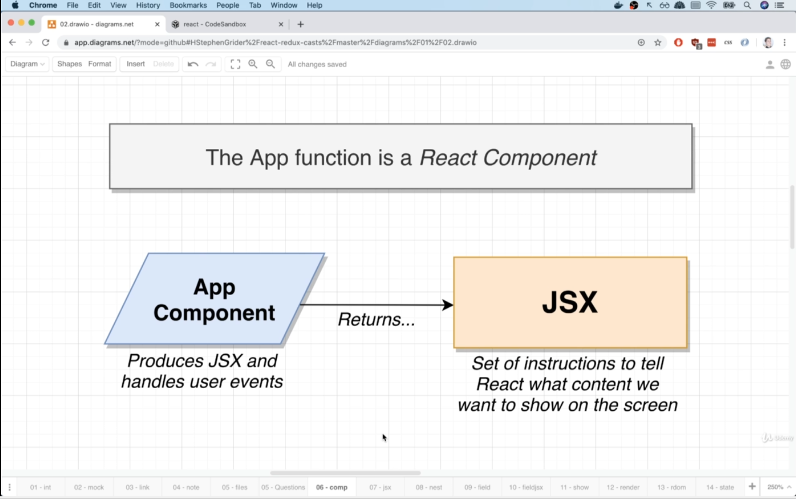

JSX 🡪 To write html and JS together like mixed.

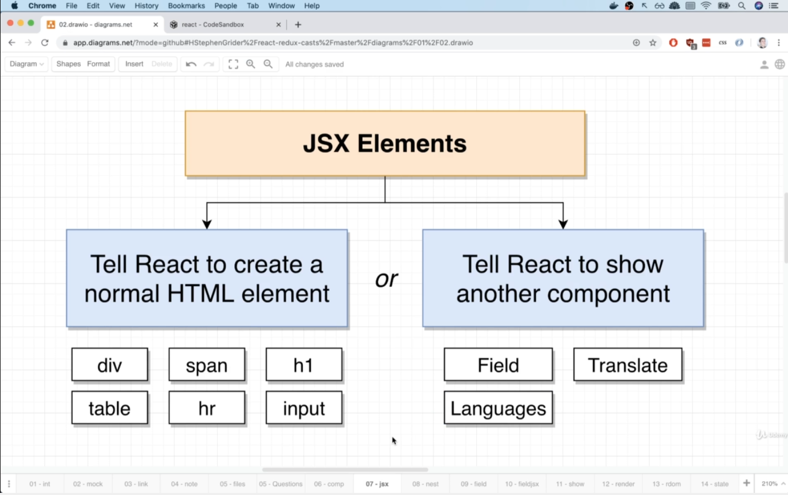

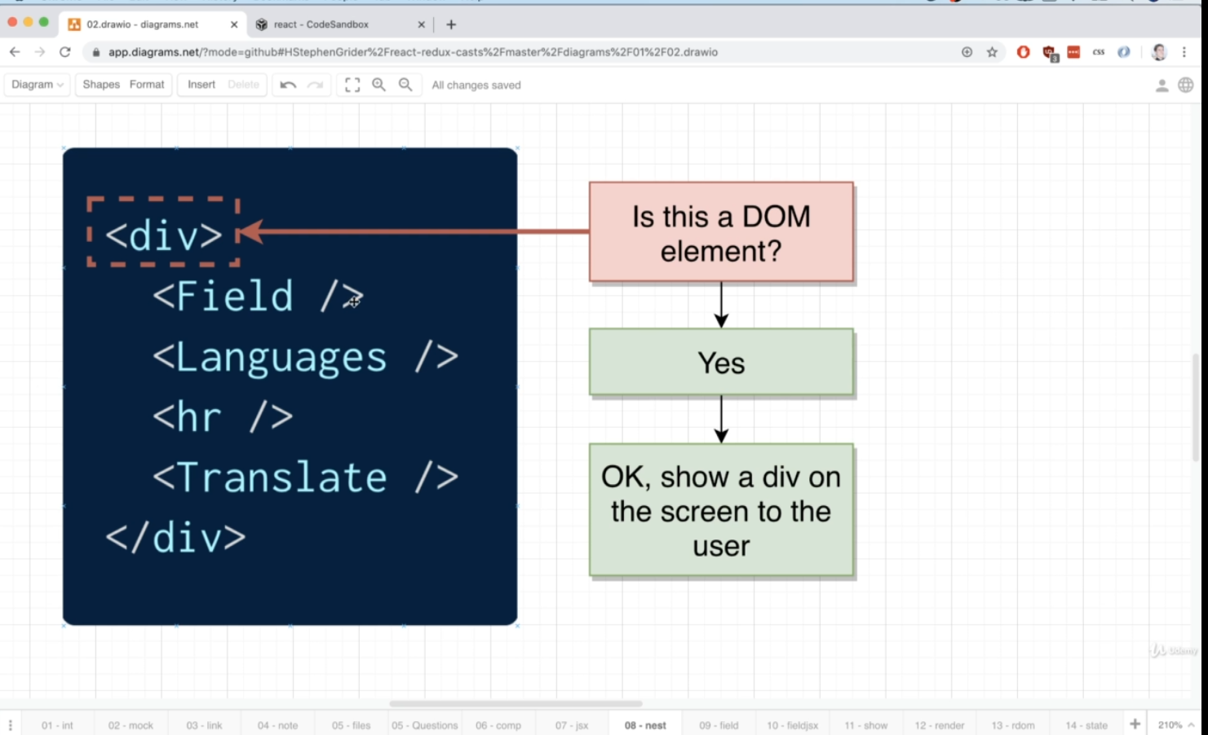

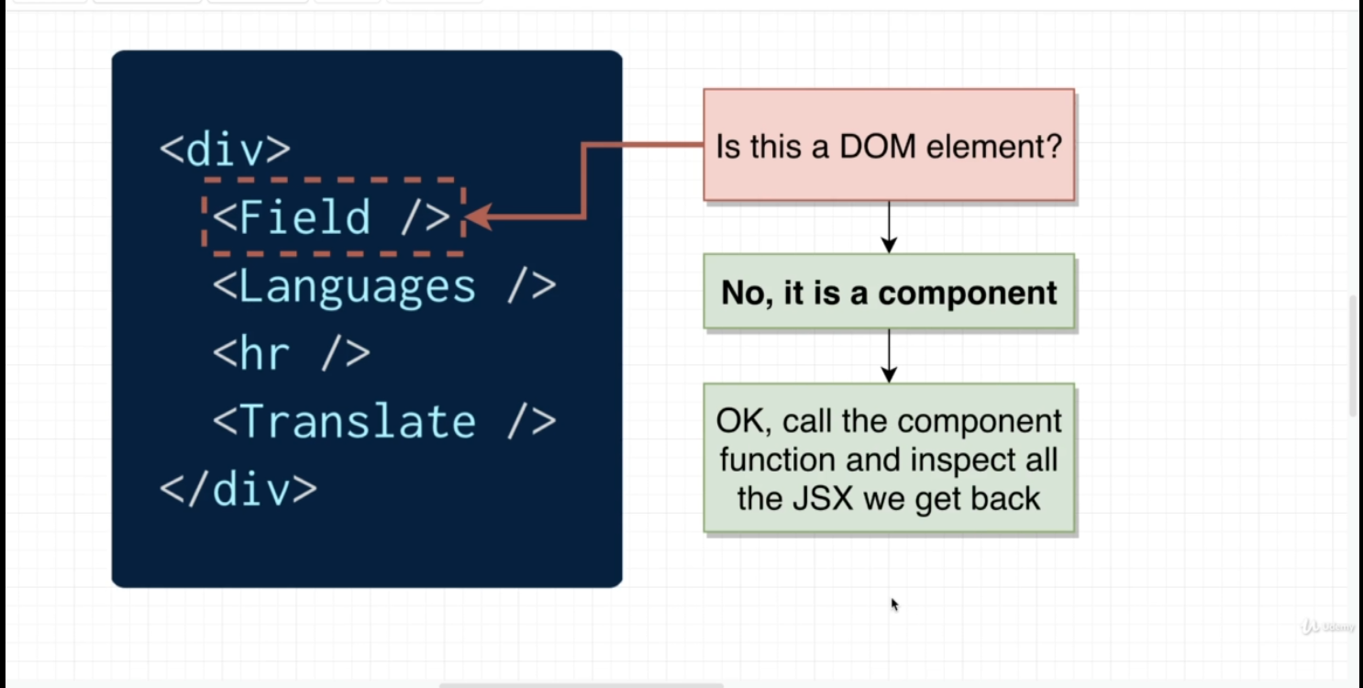

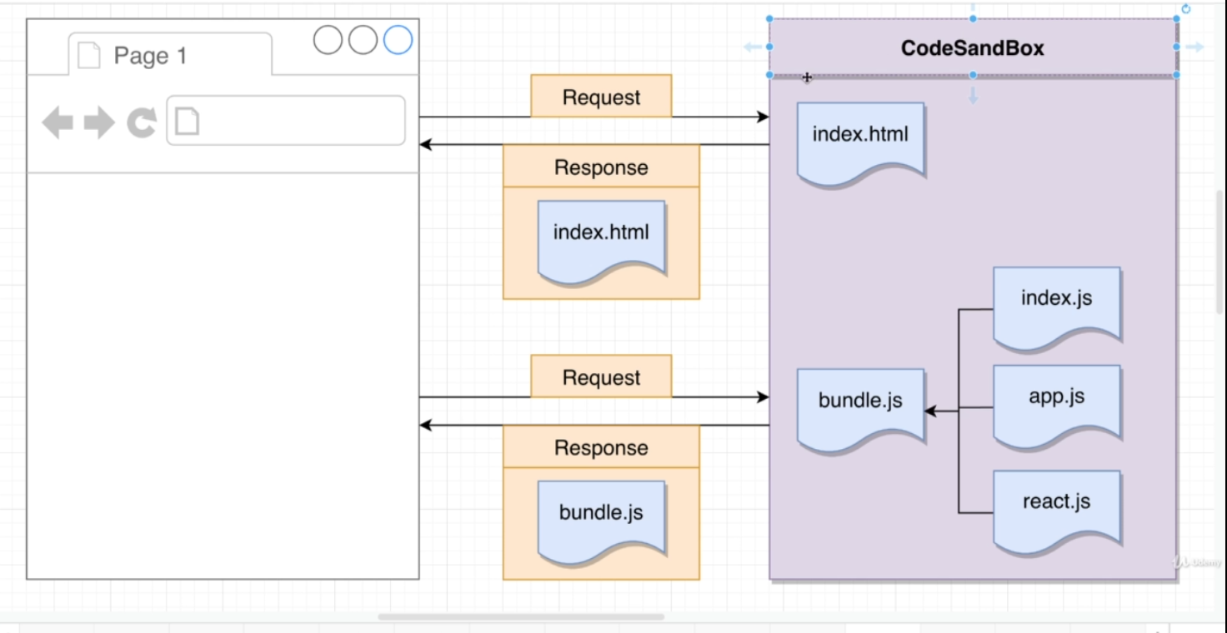

Flow 🡪

First file that gets executed is Index.js(Boots up react application)🡪

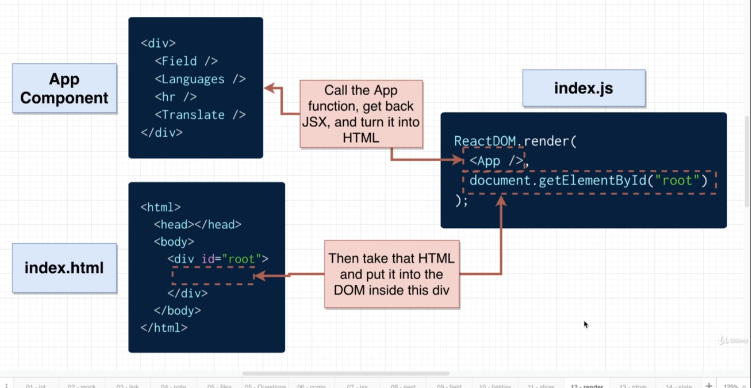

React Vs ReactDOM 🡪

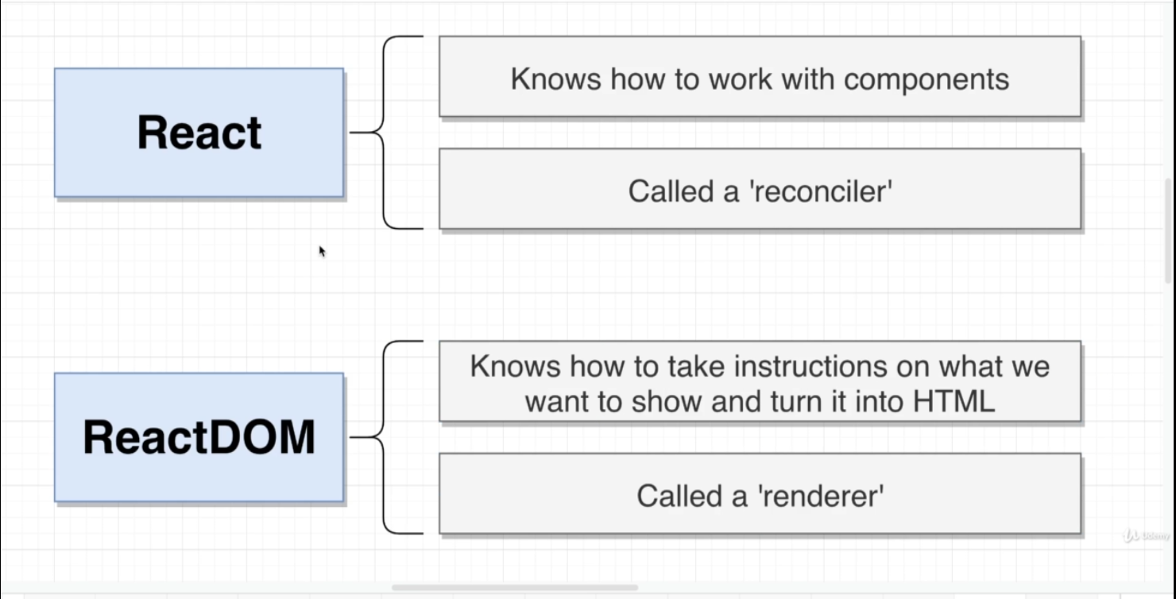

useState 🡪

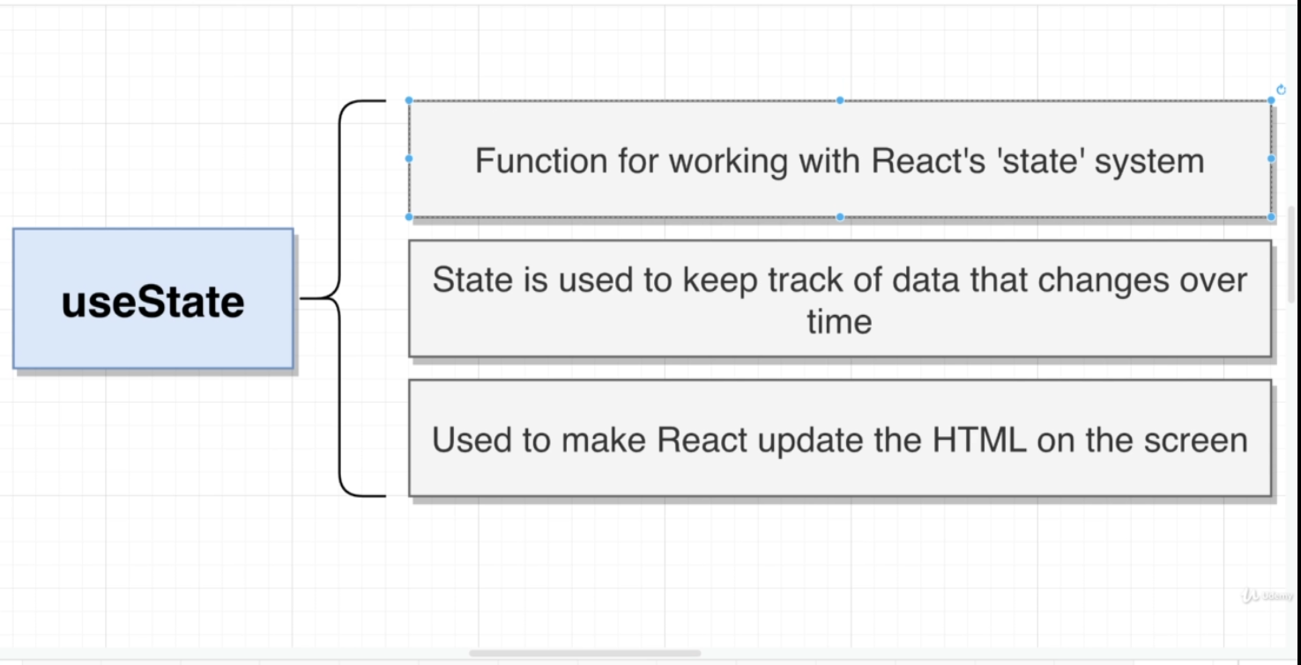

NPM 🡪

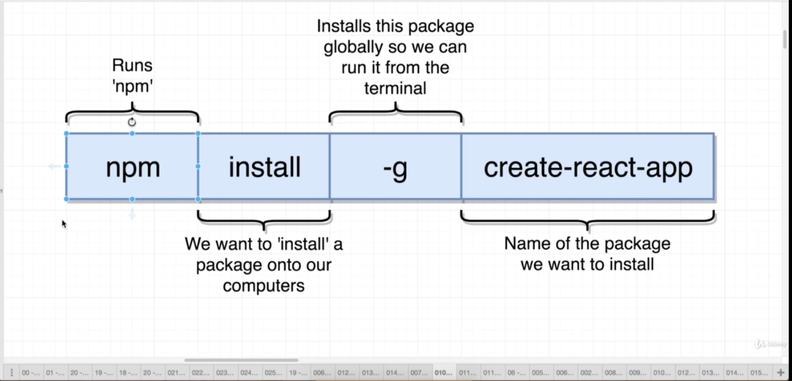

NPM is a package manager, you can install node.js packages using NPM

NPX is a tool to execute node.js packages.

It doesn't matter whether you installed that package globally or locally. NPX will temporarily install it and run it. NPM also can run packages if you configure a package.json file and include it in the script section.

So remember this, if you want to check/run a node package quickly without installing locally or globally use NPX.

np**M** - Manager

np**X** - Execute - easy to remember

About create-react-app 🡪

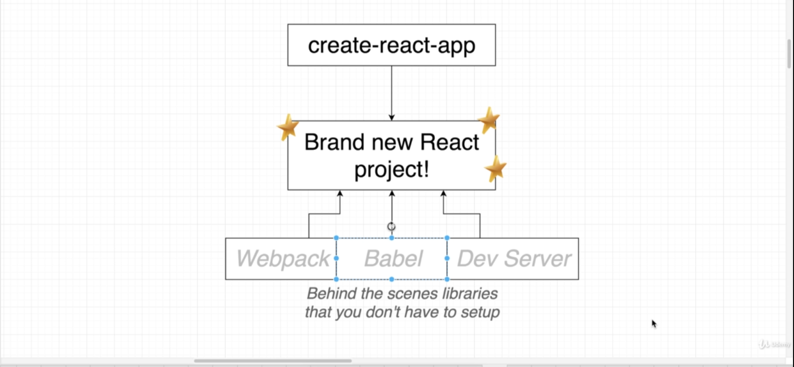

When you create your first project using create-react-app, some files will be there 🡪

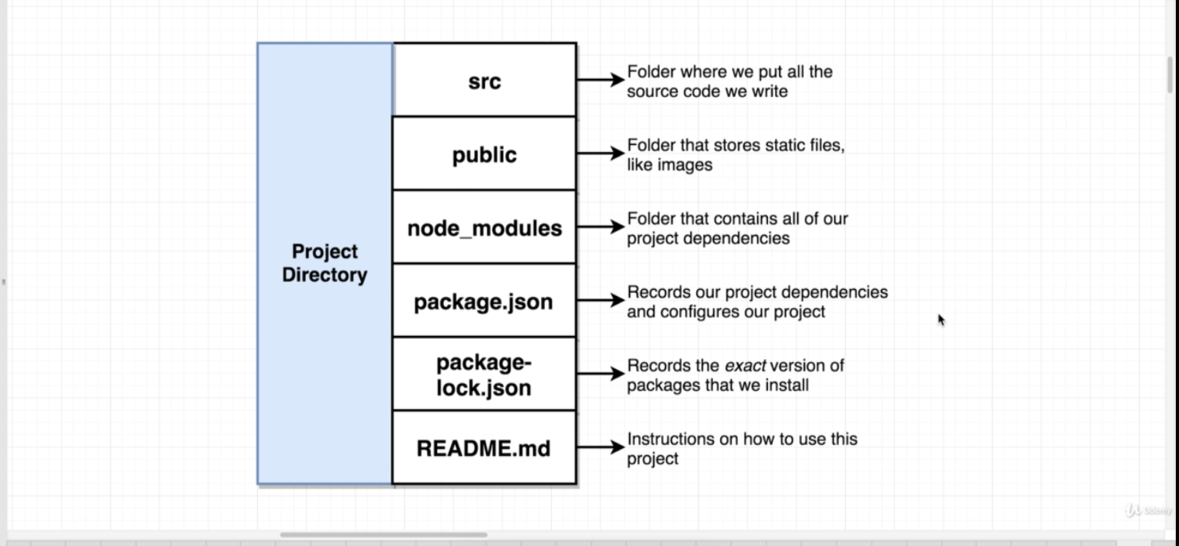

To stop and start the app 🡪

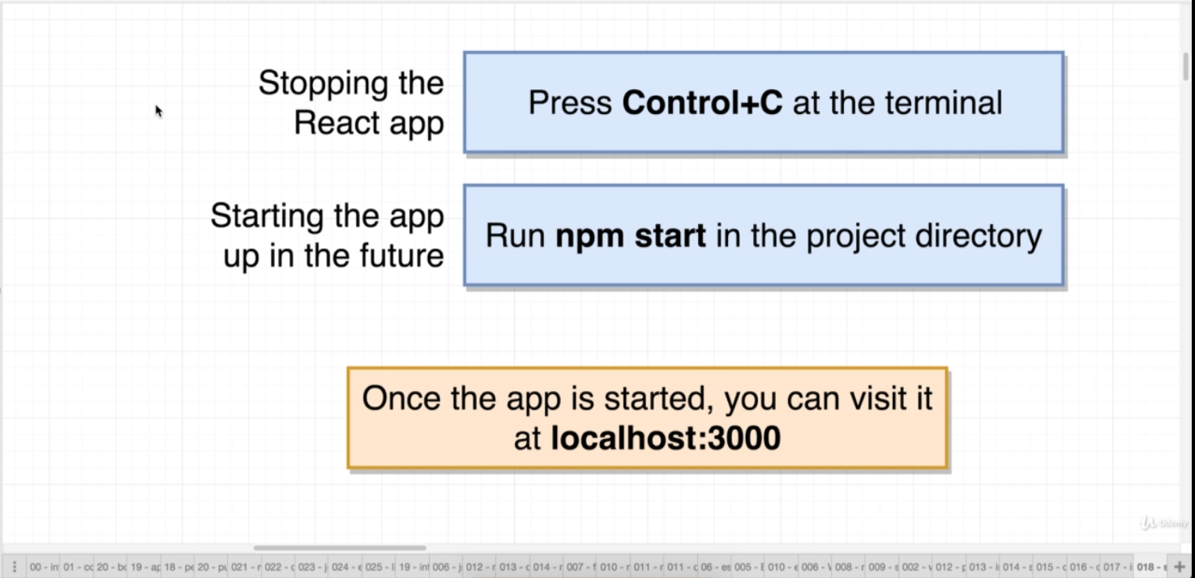

How import works 🡪

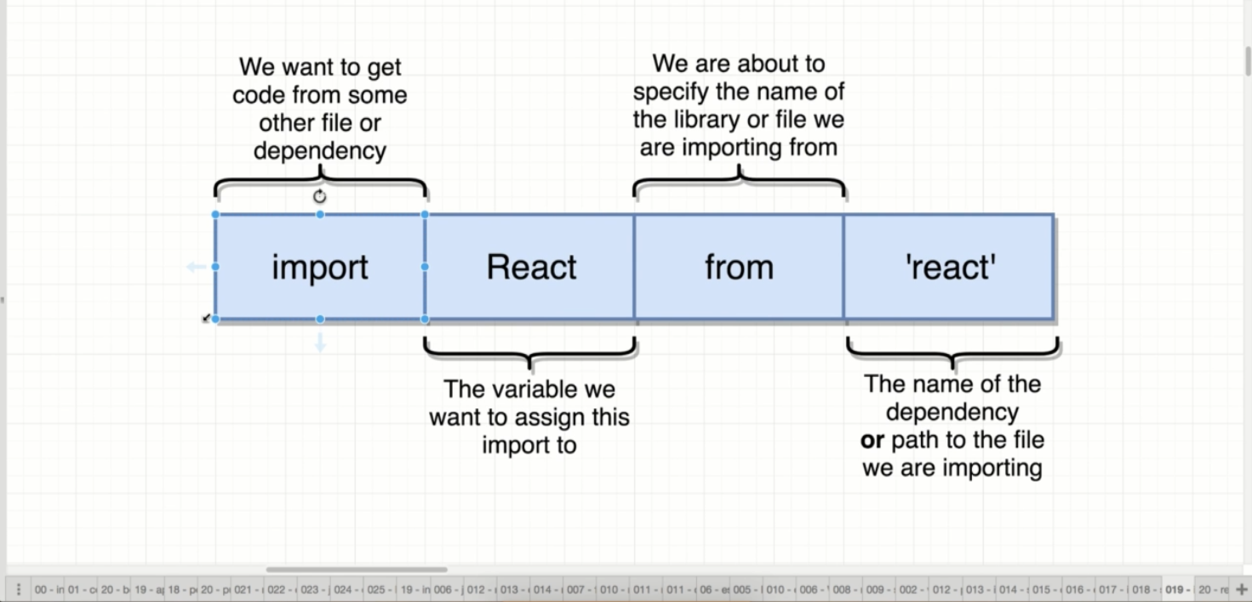

About components 🡪

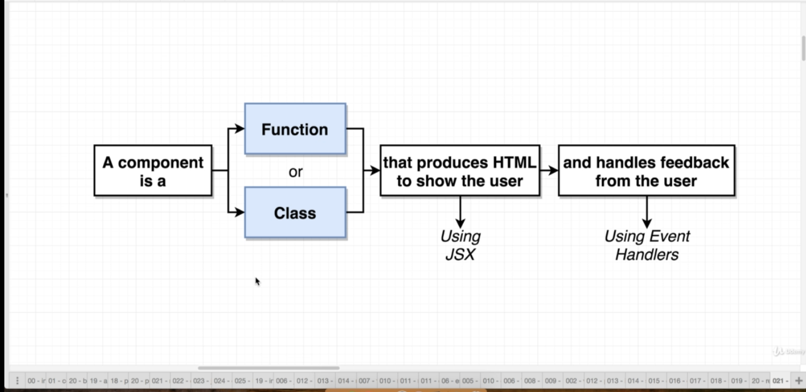

Code for basic application 🡪

//import ract and reactDOM libraries

import React from 'react';

import ReactDOM from 'react-dom';

//create react component

const App = () => {

    return <div>Hi there!!</div>

}

//Take the react component and show it on the screen

ReactDOM.render(

    <App/>,

    document.querySelector('#root')

)

JSX 🡪

JavaScript eXtension

Browser does not understand JSX.

Babel converts JSX into normal JS.

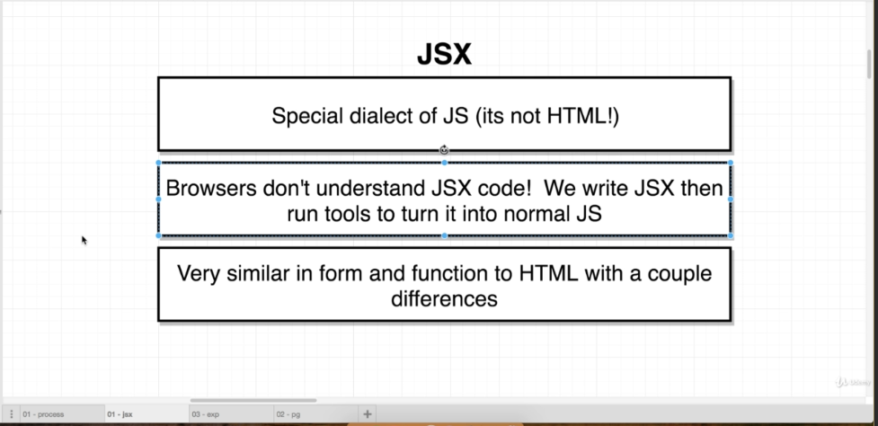

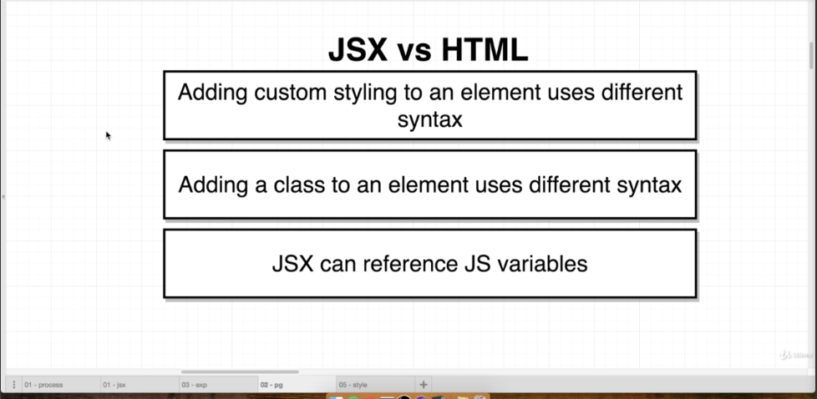

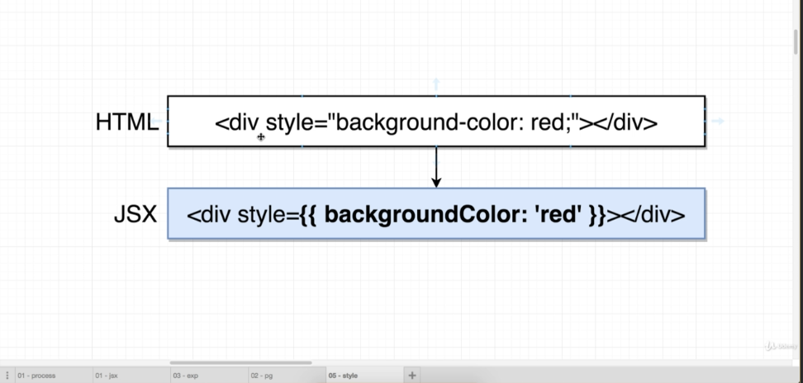

Above are the changes to convert JSX to HTML.

Outer curly braces 🡪 this is a javascript variable in JSX

Inner curly braces 🡪 JS object (background is the key and red is the value and the whole thing is an object.)

Another example 🡪

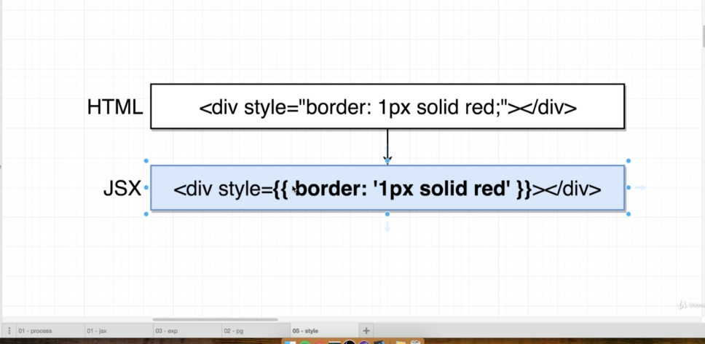

To convert properties just remove the – and capitalize it

Eg. background-color 🡪 backgroundColor

In HTML when we assign class we use class = “” 🡪

Eg <div class = “abc”><div/>

In JSX we write className 🡪

Eg. <div className = “abc”><div/>

JSX can reference/use JS variables.

const App = () =>{

    const myText = "Mohit Sharma";

    return <div>Hi there!! {myText}</div>

}

About components 🡪

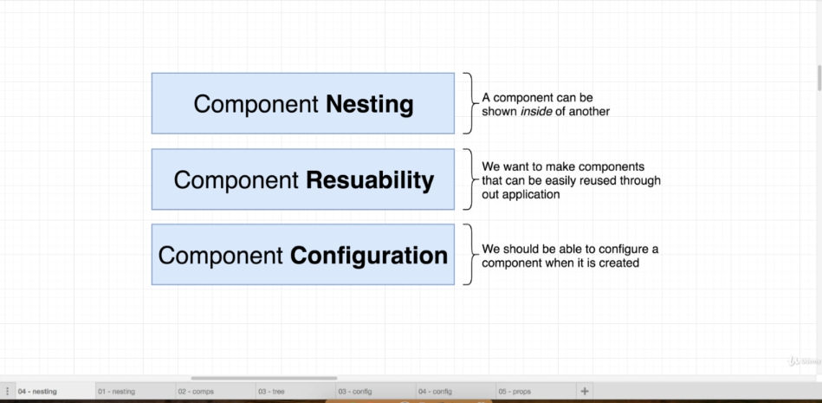

To add a css library to your project 🡪

Add line as below in the index.html file in the head tag. Index.html file will be in the public folder 🡪

    <link rel = "stylesheet" href = "https://cdnjs.cloudflare.com/ajax/libs/semantic-ui/2.4.1/semantic.min.css"/>

<https://semantic-ui.com/> 🡪

this is free library which can be used to apply basic styles for free.

<https://github.com/marak/Faker.js/> 🡪

this is free library which can be used to generate fake data. You can generate fake names, images, addresses etc and lot more. Eg I’m using an image 🡪

    <img alt = "avater" src = {faker.image.avater()}/>

Creating Components 🡪

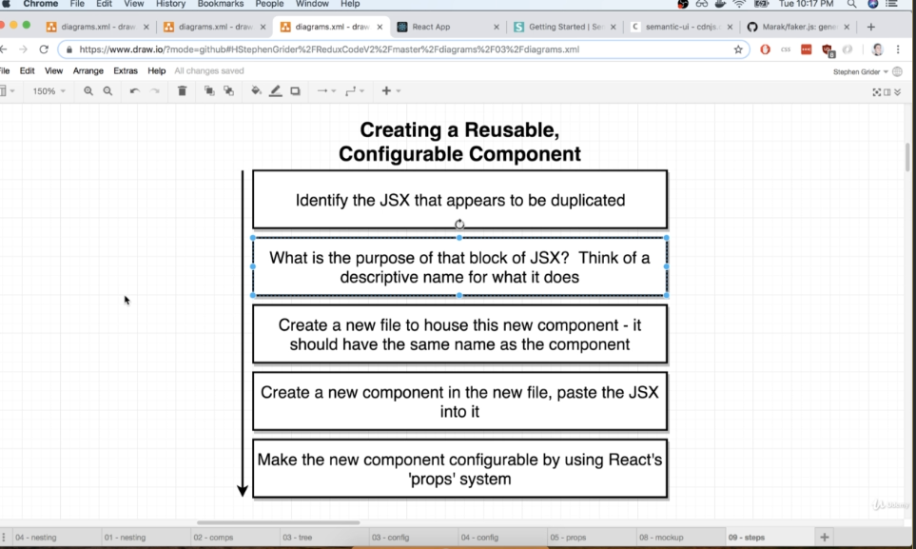

To create a component, just go to the source folder and just create a js file with your component name eg

CommentDetails.js 🡪 this component is used to show all the comment on lets say a blog post.

Make clear note of the naming convention.

Below is the content of the component 🡪

import React from "react";

const CommentDetails = () => {

    return (

     //you add your code here.

// this is inside CommentsDetails.js file

    )

}

export default CommentDetails; //here you are exporting it.

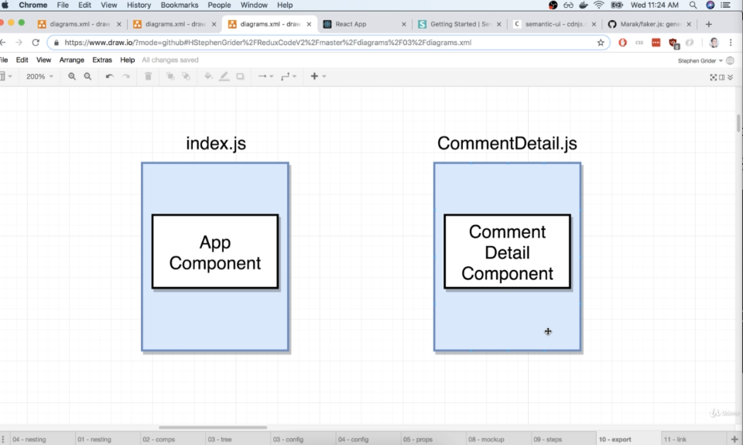

First export the component and then Import the component in the app component.

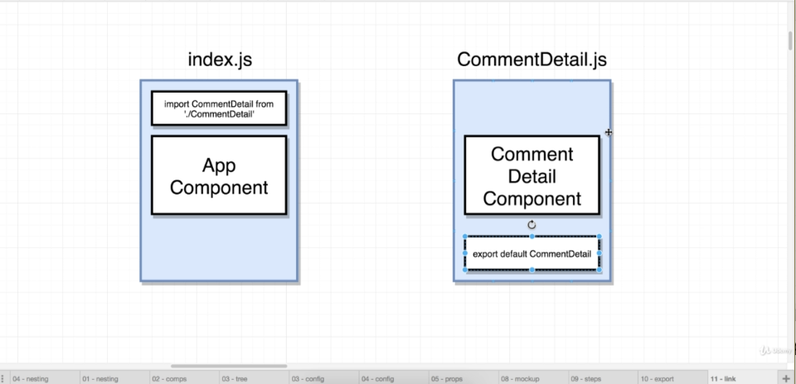

To use your created component in the app component use the custom tag 🡪

<ComponentName/>

Eg 🡪

import React from 'react'

import ReactDOM from 'react-dom'

import faker from 'faker';

import CommentDetails from './CommentDetails';

const App = () => {

    return (

        <div className ="ui container comments">

            <CommentDetails/>

//if you want to use the component multiple times

<CommentDetails/> //using it 2nd time

<CommentDetails/> //using it 3rd time

        </div>

    );

};

ReactDOM.render(<App/>, document.querySelector('#root'));

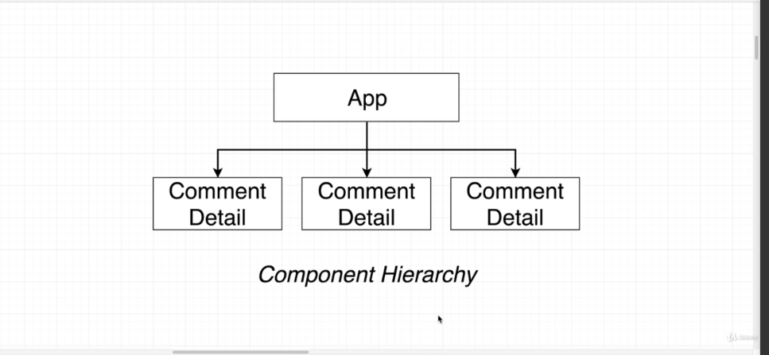

App component 🡪 parent component

ComponentDetail component 🡪 child component

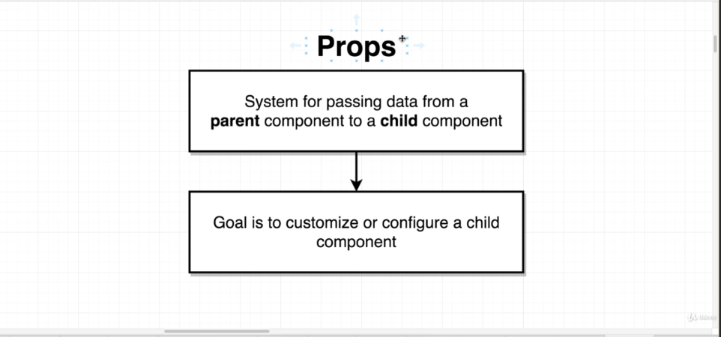

Chile component can not send data to the parent component using the props system.

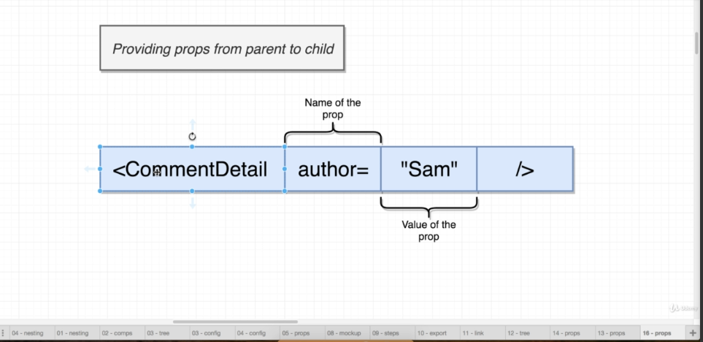

If you want to pass a js variable 🡪

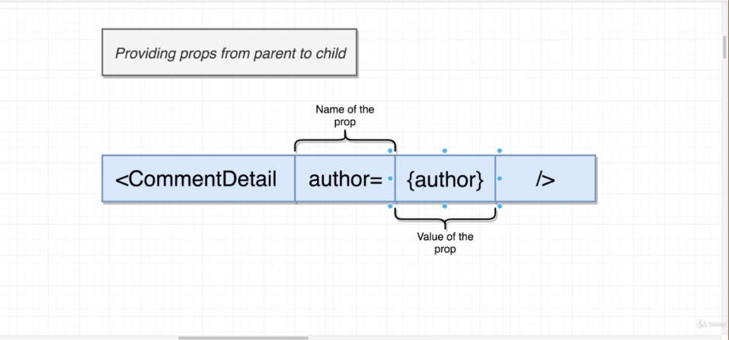

Here author is a js variable so it is written as {author}

Below is an example 🡪

Parent component (App Component) 🡪

import React from 'react'

import ReactDOM from 'react-dom'

import faker from 'faker';

import CommentDetails from './CommentDetails';

const App = () => {

    return (

        <div className ="ui container comments">

            <CommentDetails

            author = "Sam"

            timeAgo = "Today at 5PM"

            commentText ="Nice"

            imageSrc = {faker.image.avatar()}

            />

            <CommentDetails

            author = "Jane"

            timeAgo = "Today at 2:45PM"

            commentText ="Well Done"

            imageSrc = {faker.image.avatar()}

            />

            <CommentDetails

            author = "Alex"

            timeAgo = "Yesterday at 5PM"

            commentText ="Wow"

            imageSrc = {faker.image.avatar()}

            />

        </div>

    );

};

ReactDOM.render(<App/>, document.querySelector('#root'));

imageSrc is not a string but refers to a JS variable that is why it is not inside “” but inside {}.

Here is the CommentDetail component 🡪

import React from "react";

const CommentDetails = props=>{

    console.log(props)

    return(

        <div className = "comment">

        <a href = "/" className = "avater">

        <img alt="avatar" src={props.imageSrc} />

        </a>

        <div className = "content">

            <a href ="/" className = "auther">

                {props.author}

            </a>

            <div className = "metadata">

            <span className = "date">{props.timeAgo}</span>

            </div>

            <div className ="text">{props.commentText}</div>

        </div>

    </div>

    )

}

export default CommentDetails;

New component 🡪

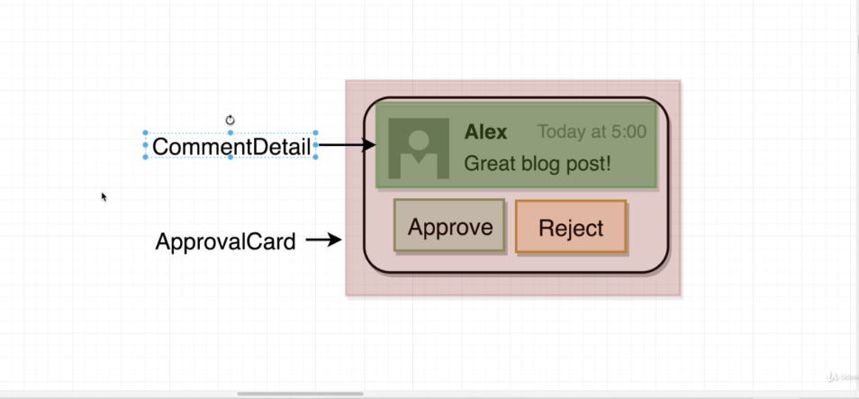

We want to set it up like shown above.

I want to show the CommentDetail component inside the ApprovalCard component.

Code for App Component 🡪

import React from 'react'

import ReactDOM from 'react-dom'

import faker from 'faker';

import CommentDetails from './CommentDetails';

import ApprovalCard from './ApprovalCard';

const App = () => {

    return (

        <div className ="ui container comments">

            <ApprovalCard>

                <CommentDetails

                author = "Sam"

                timeAgo = "Today at 5PM"

                commentText ="Nice"

                imageSrc = {faker.image.avatar()}

                />

            </ApprovalCard>

            <ApprovalCard>

                <CommentDetails

                author = "Jane"

                timeAgo = "Today at 2:45PM"

                commentText ="Well Done"

                imageSrc = {faker.image.avatar()}

                />

             </ApprovalCard>

             <ApprovalCard>

                <CommentDetails

                author = "Alex"

                timeAgo = "Yesterday at 5PM"

                commentText ="Wow"

                imageSrc = {faker.image.avatar()}

                />

             </ApprovalCard>

        </div>

    );

};

ReactDOM.render(<App/>, document.querySelector('#root'));

Here im using <ApprovalCard> as a tag and I am passing CommentDetail component as a children component. Now I can use it in the ApprovalCard component as 🡪

Code for ApprovalCard component 🡪

import React from 'react';

const ApprovalCard = (props) => {

    console.log(props.children)

    return(

        <div className = "ui card">

            <div className="content">

               {props.children}

            </div>

            <div className='extra content'>

                <div className='ui two buttons'>

                    <div className='ui basic green button'>

                        Approve

                    </div>

                    <div className='ui basic red button'>

                        Reject

                    </div>

                </div>

            </div>

        </div>

    )

}

export default ApprovalCard

Here I use {props.children} to show whatever child component I pass to this component. This way we can pass a component to other component as a children and show it there.

UI 🡪

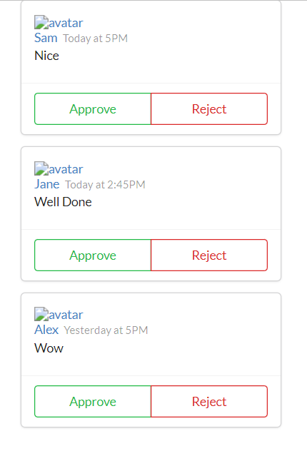

It is not necessary that I pass the component only, I can pass JSX code as a children as well as 🡪

UI 🡪

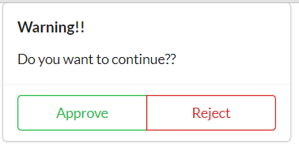

Code 🡪

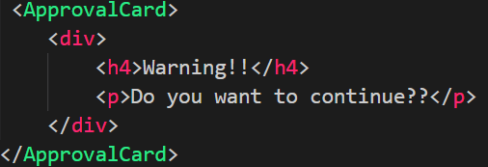

ApprovalComponent Code 🡪

import React from 'react';

const ApprovalCard = (props) => {

    console.log(props.children)

    return(

        <div className = "ui card">

            <div className="content">

               {props.children}

            </div>

            <div className='extra content'>

                <div className='ui two buttons'>

                    <div className='ui basic green button'>

                        Approve

                    </div>

                    <div className='ui basic red button'>

                        Reject

                    </div>

                </div>

            </div>

        </div>

    )

}

export default ApprovalCard

Here I pass JSX code to the ApprovalCard component instead of another component. Now this code is the child component and it is being shown in the approval box.

**{props.children} is used to show the child component that is passed.**

**Class Based components 🡪**

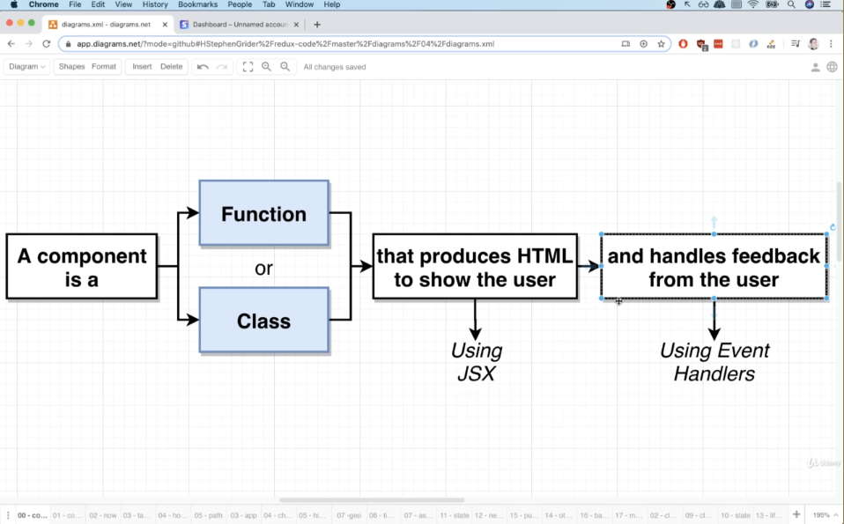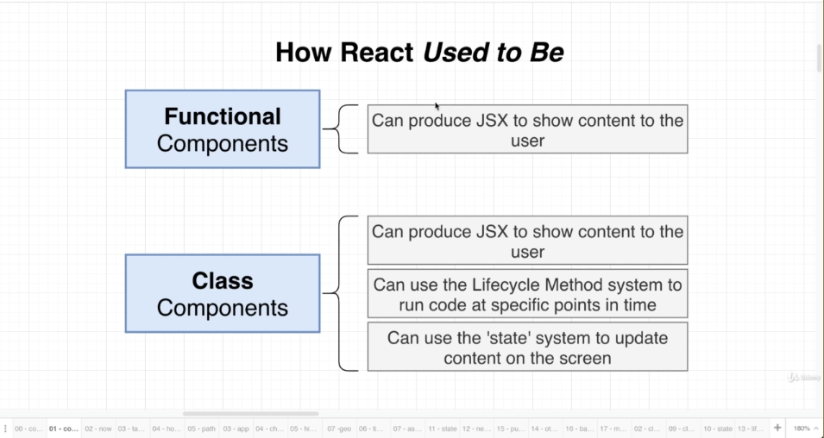

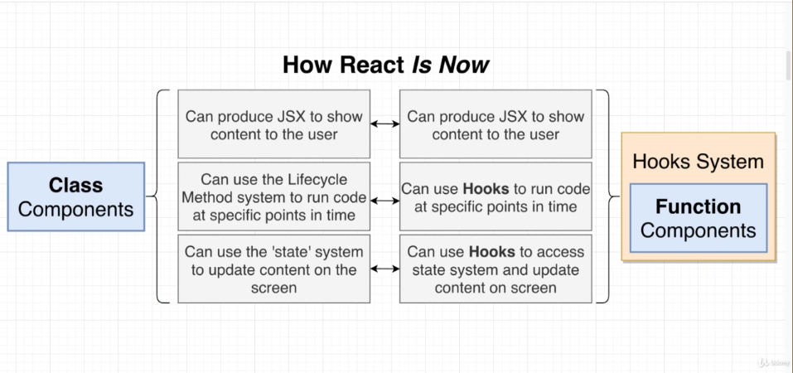

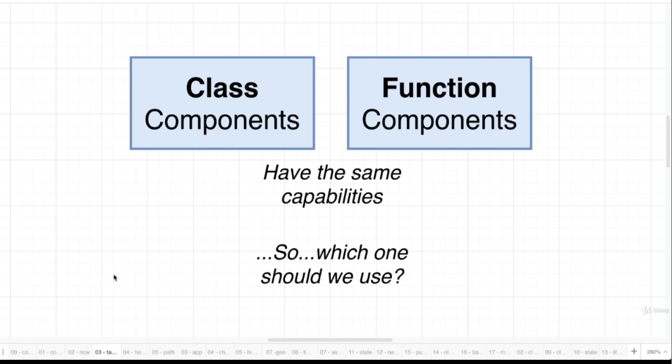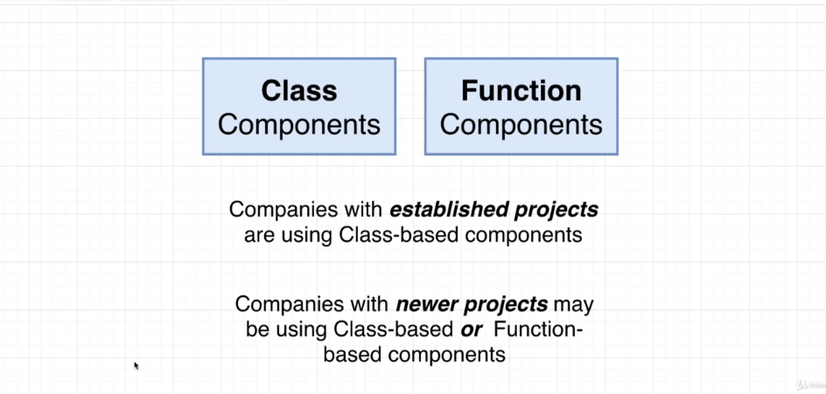

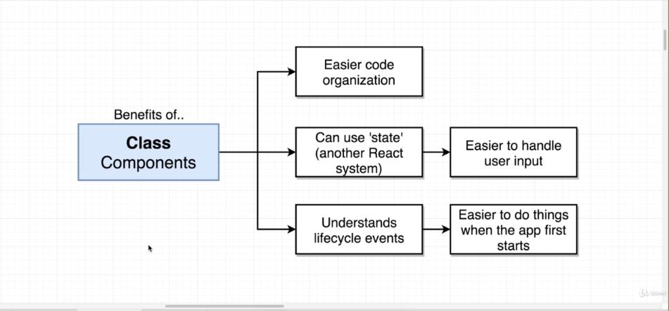

Application we are building 🡪

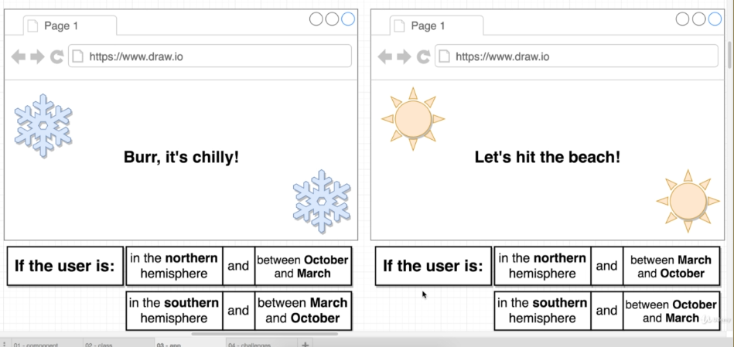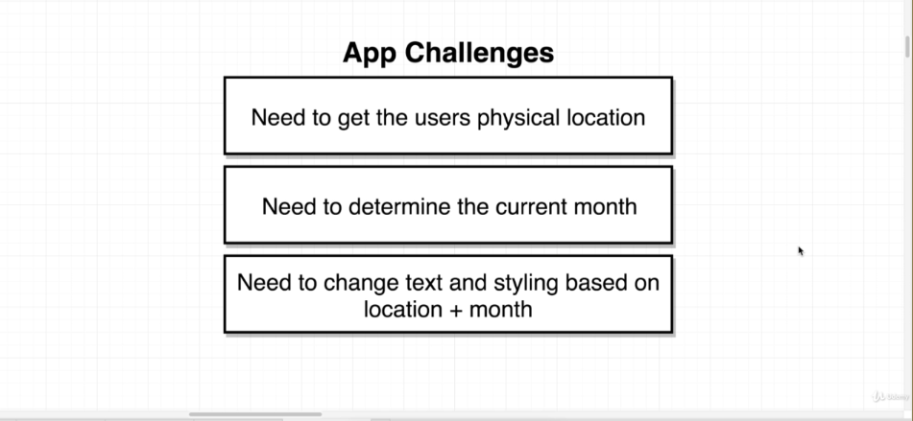

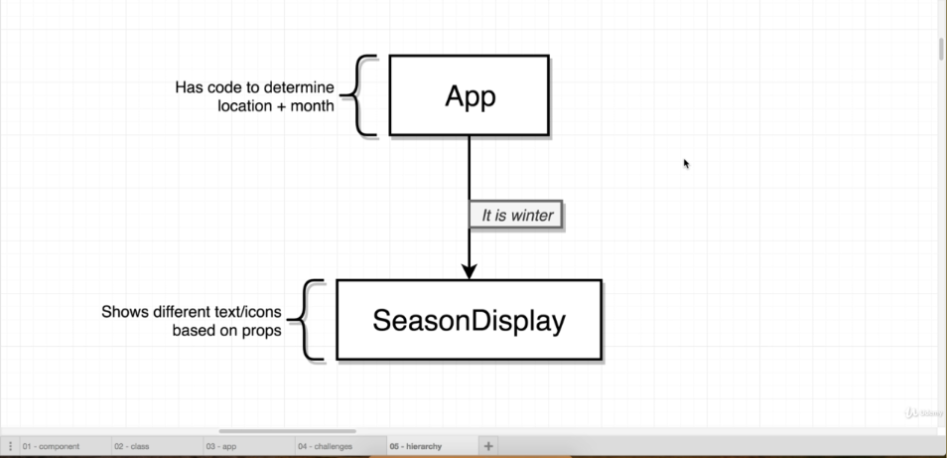

To get loction 🡪

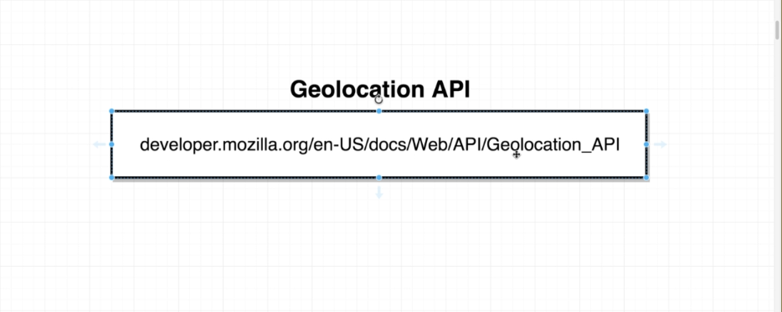

Code for app🡪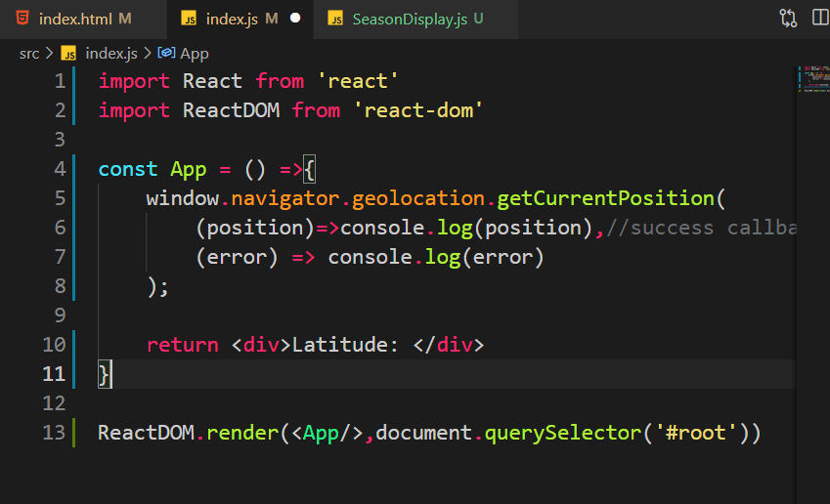

**Flow of this app 🡪**

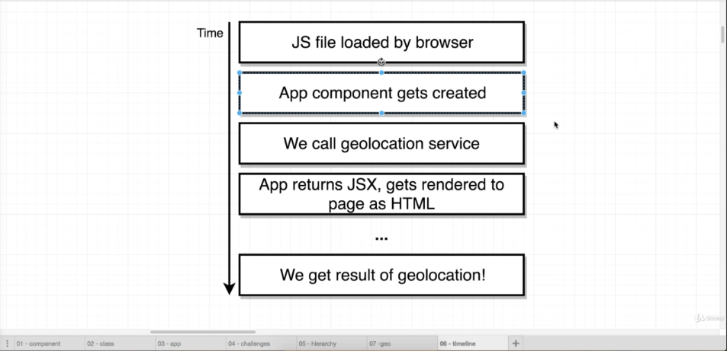

But we need this:

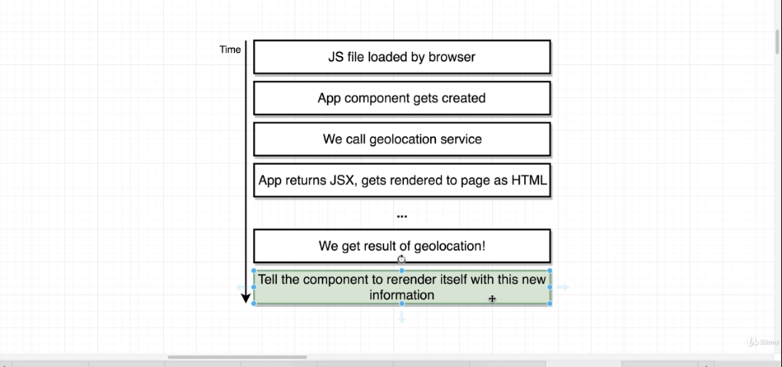

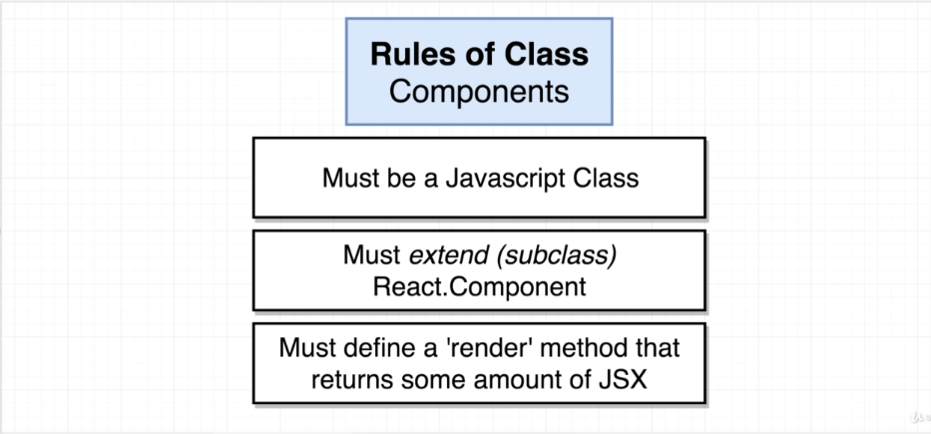

Class component vs class component 🡪

// const App = () => {

    // window.navigator.geolocation.getCurrentPosition(

    //     (position)=>console.log(position),

    //     (error) => console.log(error)

    // );

//     return <div>Latitude: </div>

// }

class App extends React.Component{

    render(){

        window.navigator.geolocation.getCurrentPosition(

            (position)=>console.log(position),

            (error) => console.log(error)

        );

        return <div>Latitude: </div>

    }

}

States in React 🡪

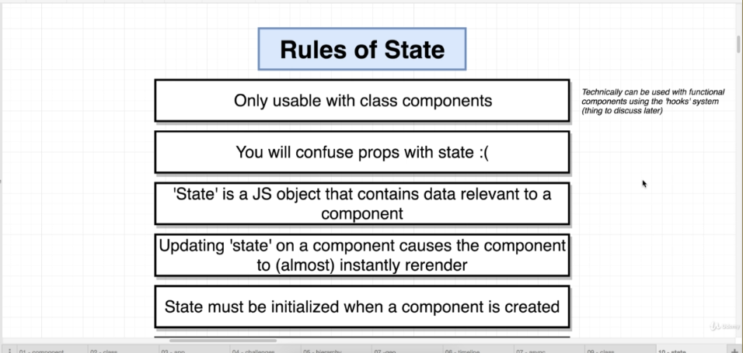

Important 🡪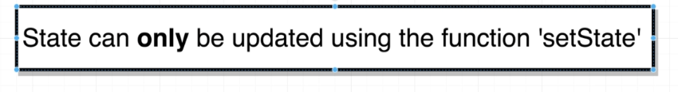

Constructor in Class based component 🡪

 constructor(props) {

        super(props); //Compulsory

    }

State Initialization 🡪

   constructor(props){

        super(props);

        this.state = {lat: null};   //Initialising State

    }

Lat means latitude because we want latitude here in the state.

Render() method in the class gets called very frequently so we have removed call to geolocation method to the constructor.

constructor(props){

        super(props);

        this.state = {lat: null};   //Initialising State

        window.navigator.geolocation.getCurrentPosition(

            (position)=>console.log(position),

            (error) => console.log(error)

        );

    }

This is the complete code to get latitude using state 🡪

import React from 'react'

import ReactDOM from 'react-dom'

class App extends react.Component{

    constructor(props){

        super(props);

        this.state = {lat: null};   //Initialising State

        window.navigator.geolocation.getCurrentPosition(

            (position)=>{

                this.setState({ lat: position.coords.latitude })

            },

            (error) => console.log(error)

        );

    }

    render(){

        return <div>Latitude: {this.state.lat}</div>

    }

}

ReactDOM.render(<App/>,document.querySelector('#root'))

Full flow 🡪

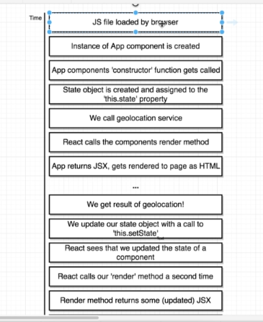

App component here gets rendered twice here, first when app gets loaded, second when we get the position.

This happens because when state gets updated the component gets rendered again.

Any time you want to re-render your component you just need to update the state and component gets re-rendered automatically.

We are showing like this:

If we get the location:

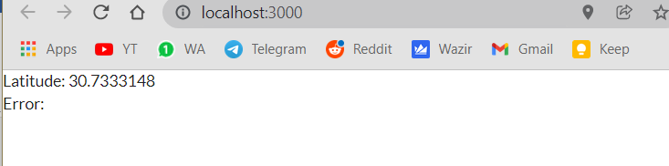

If we don’t:

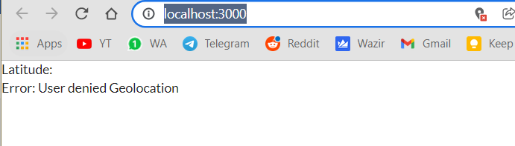

Combination:

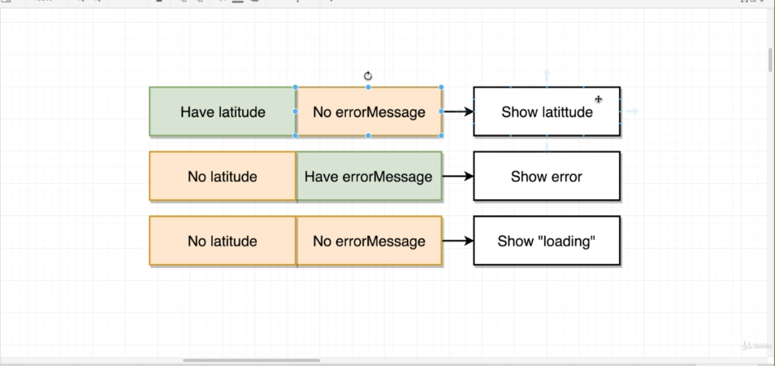

For conditional rendering 🡪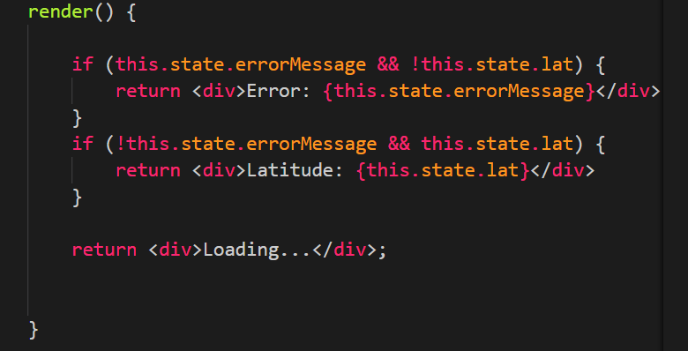

Life cycle methods 🡪

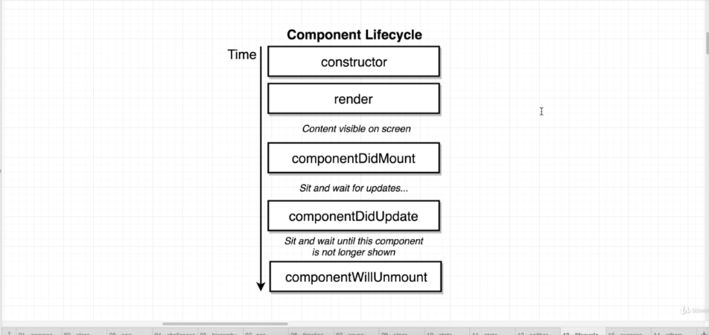

Stages of the component like creation, update and destruction.

These are lifecycle events.

componentDidMount() 🡪 This method can be defined in the component class and will be called when the component is first rendered. Only once…

componentDidUpdate() 🡪 whenever the component is updated ie whenever we call the state update method. So, whenever we are going to update the state, this method will be called and the code will be executed. Render() will be called exactly before this.

componentDidUnmount() 🡪 whenever the component is unmounted or destroyed then this method will be called.

Note: not the entire methods but these are the main once. Others are not used at all.

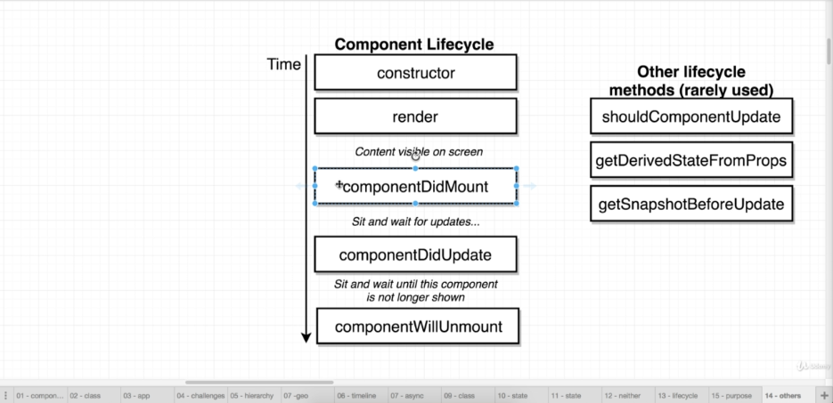

Uses of Life Cycle methods 🡪

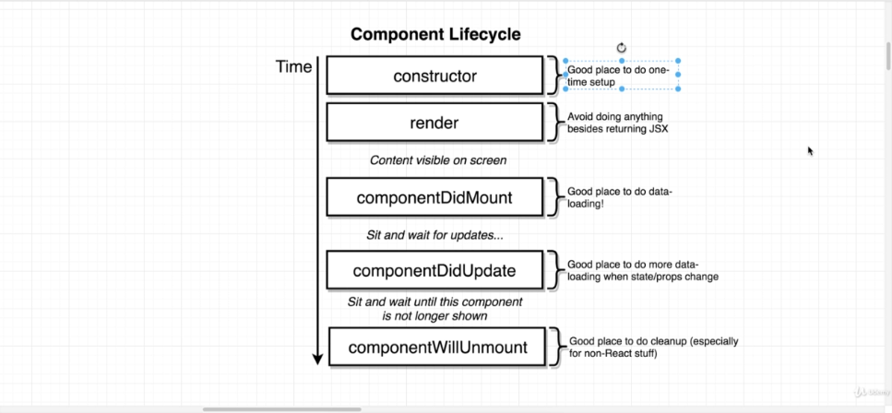

Two ways to initialize state 🡪 using the constructor (less used):

constructor(props) {

        super(props);

        this.state = { lat: null, errorMessage: '' };   //Initialising State

    }

Directly (more used):

 state = {lat: null, errorMessage: ''};

both are same actually but in the below one babel will convert it to the above one but here you would not need to write the whole code. So bottom is good.

We can also pass state as a prop to the component as🡪

<SeasonDisplay lat={this.state.lat}/>

SeasonDisplay is a component and we are passing out state variable lat as a prop.

If lat changes the SeasonDisplay will also be reloaded.

Here is how it is accepted in the component(Just like any normal prop) 🡪

const SeasonDisplay = (props) =>{

    console.log(props.lat)

    return<div>Hi There</div>

}

You can also create configuration part for your component. Below is the example. Read it carefully and you will understand 🡪

import React from 'react'

const seasonConfig = {

    summer:{

        text: "Let's hit the beach",

        iconName: "sun"

    },

    winter:{

        text: "Burr, It is Cold",

        iconName: "snowflake"

    }

}

const getSeason = (lat,month)=>{

if(month>2 && month <9){

    return lat>0 ? 'summer': 'winter';

}

else{

    return lat>0 ? 'winter': 'summer';

}

}

const SeasonDisplay = (props) =>{

    const season = getSeason(props.lat, new Date().getMonth());

    const {text, iconName} = seasonConfig[season]//{text,iconName}

    return(

    <div>

        <i className={`${iconName} icon`}/>

        <h1>{text}</h1>

        <i className={`${iconName} icon`}/>

    </div>

    );

}

export default SeasonDisplay;

//<i class="disabled snowflake icon"></i>

How to import css file to a component 🡪

In the first line of the component, you can write 🡪

import './SeasonDisplay.css'

When we use components, we sometimes may forget to pass the props. In that case we will use default props. Here 🡪

ComponentName.defaultProps{

Prop1: defaultValue;

Prop2: defaultValue;

…….

} //inside the component

Take a look at this Spinner component 🡪

import React from 'react'

const Spinner = (props) =>{

    return(

        <div className='ui active dimmer'>

        <div className='ui big text loader'>{props.message}</div>

        </div>

    )

}

Spinner.defaultProps = {

    message: "Loading..."

}

export default Spinner;

if we pass the prop message then that is shown; otherwise Loading… is shown.

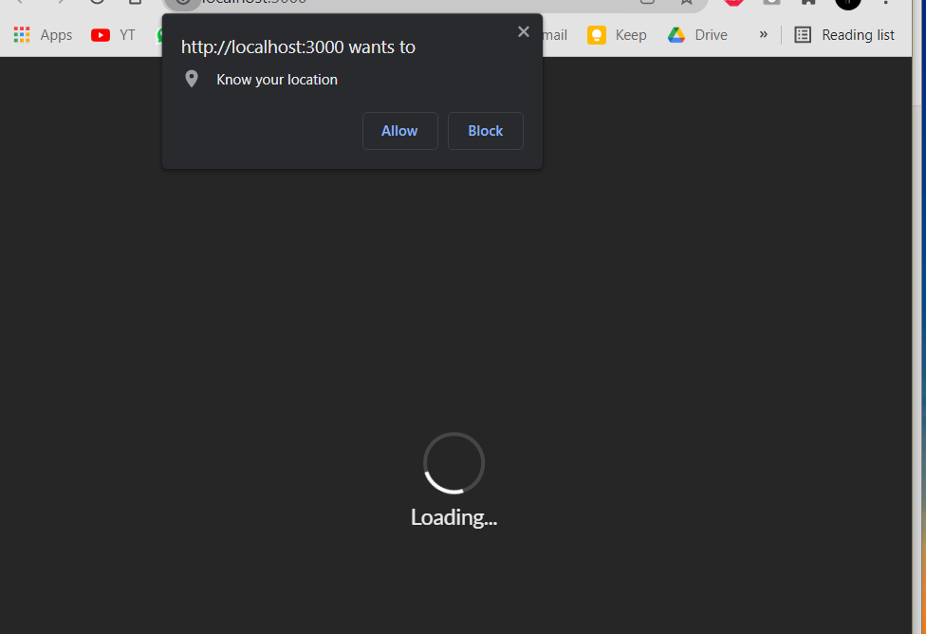

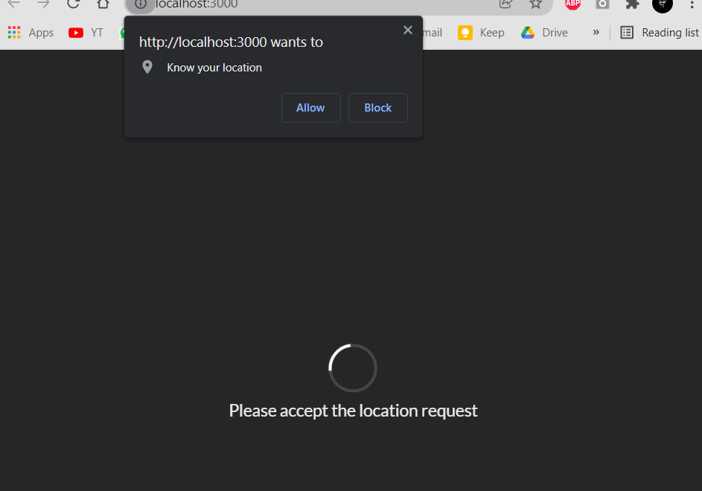

React Forms and Dealing with events 🡪

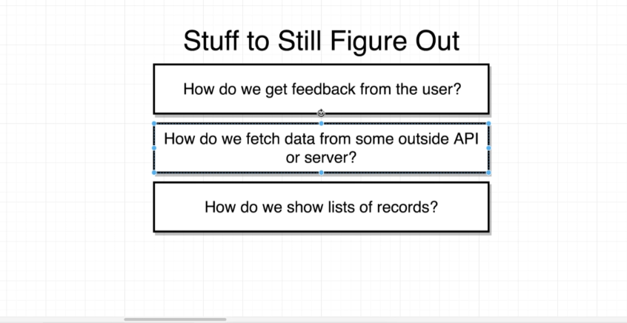

Application we will develop here 🡪

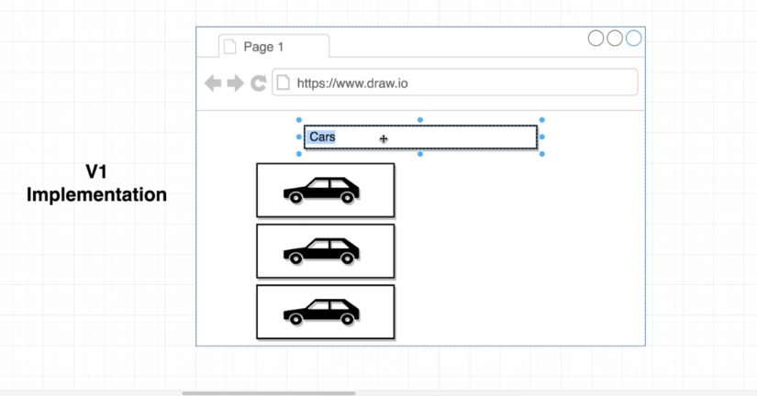

User will type some word in the box and then we will show the user that object’s pictures 🡪

Eg here user has entered car and we are showing the user car pictures.

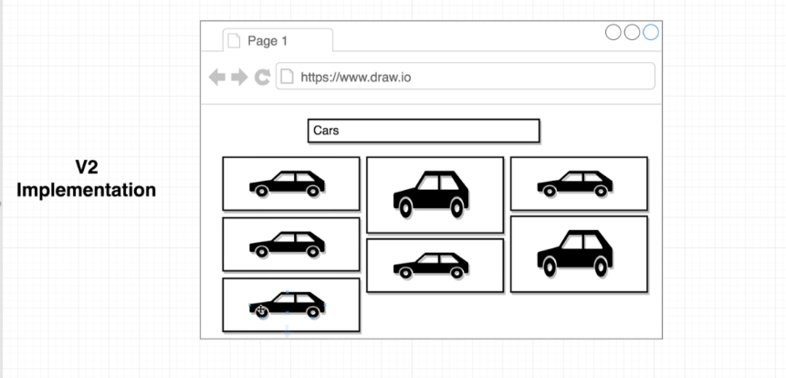

In V2, we will tile the pictures as shown. As shown above. More styling required.

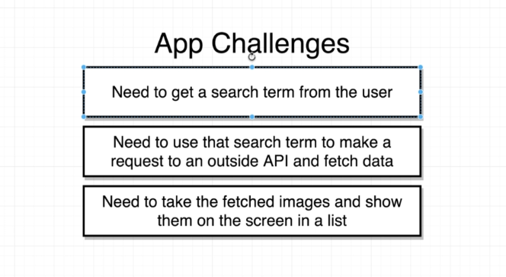

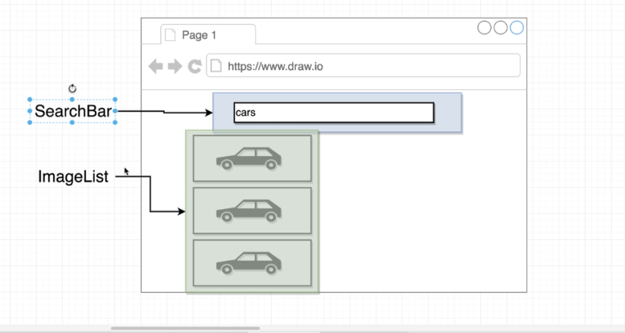

Components 🡪

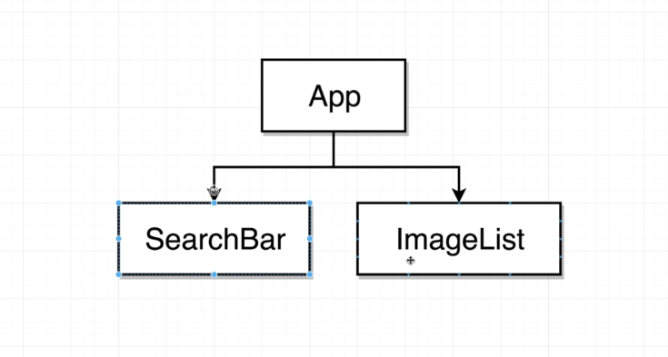

**Always create your components inside the component folder in src folder in you project.**

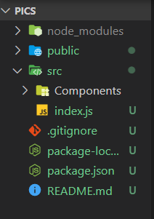

To add events to html components 🡪

We will add a method to the search bar 🡪

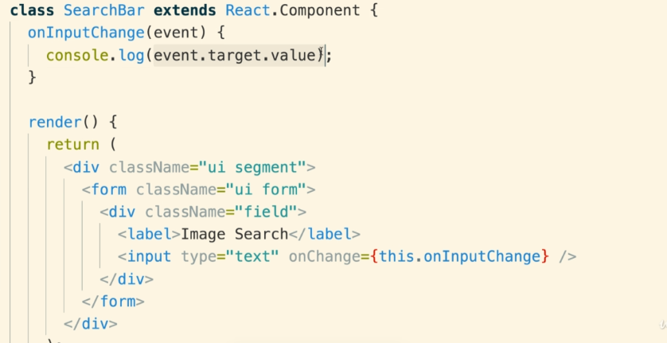

**Note: we did not add () after the call to onInputChange. If we write it as onInputChange() then the method will be called every time we will call the render method ie every time the component will be rendered.**

Here, in the method we accept an argument which is event. This is automatically passed and does not need to be explicitly passed. This will conatin information about the event. Here event contains the information like the value entered by the user in the field ie event.target.value

Also onChange prop on the input tag is a special prop and will call the method whenever the field will change.

There are many others 🡪

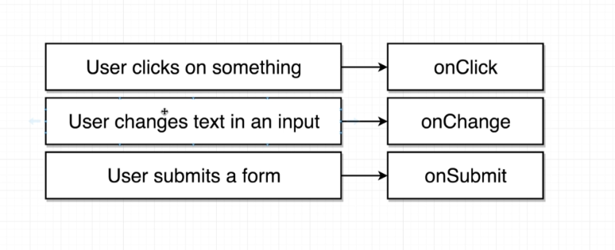

They can be mostly applied on any component but not on all the component.

Eg we cant apply onChange on <div> bc it never changes.

Alternate syntax 🡪

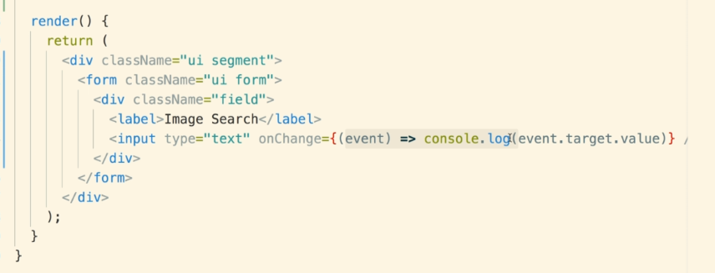

Using arrow function for an event.

Type of field 🡪

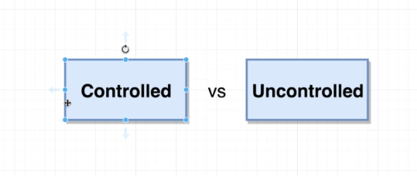

We will refactor our code to make it a controlled field 🡪

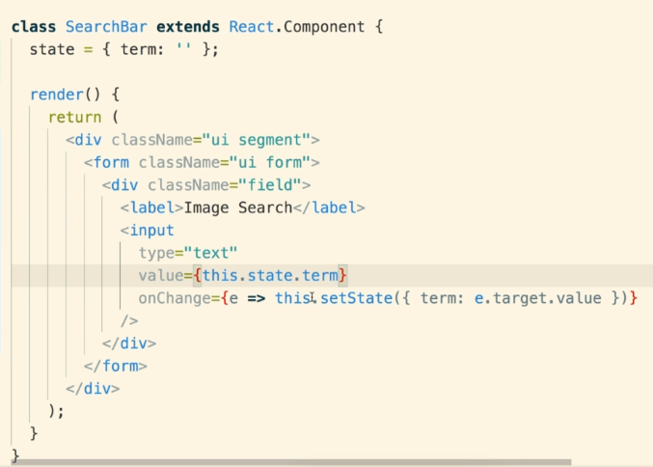

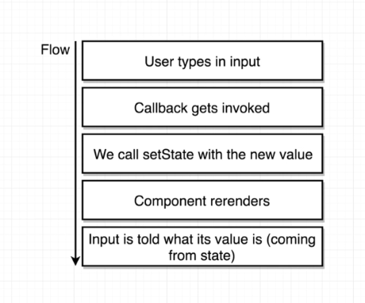

Now that is a controlled element.

Difference 🡪 Uncontrolled Version 🡪

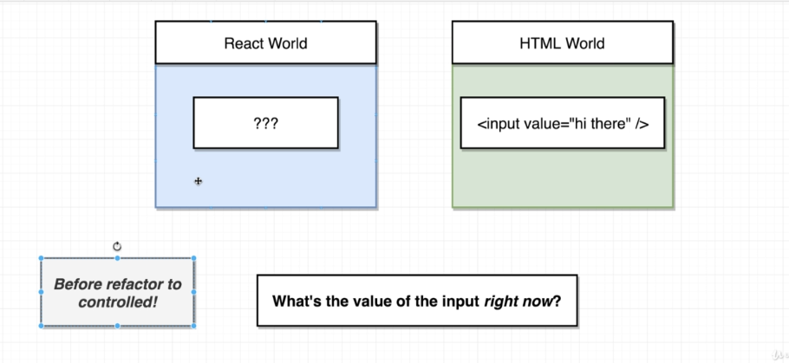

We don’t know the value of the input element. It was contained in the HTML and react was unaware of this until we pull it from the DOM, this is bad.

Controlled Version 🡪

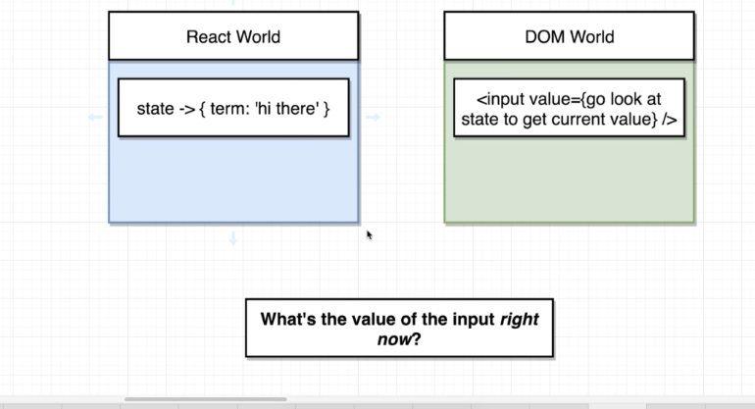

React knows the value of the input at all times because of the state variable.

We don’t need to go to the DOM to get the values. We have it in the state.

If you want to stop the default behaviour of an element, you can use –

   event.preventDefault();

Sometimes you get this error (very common) 🡪

SearchBar.js:8 Uncaught TypeError: Cannot read properties of undefined (reading 'state')

Basically they cant read the state object.

Lets understand this keyword --.

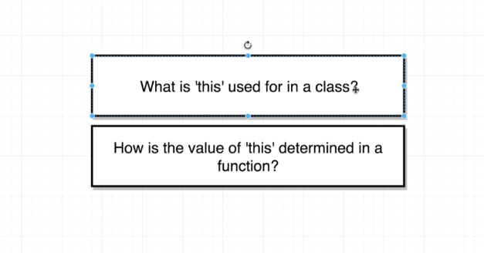

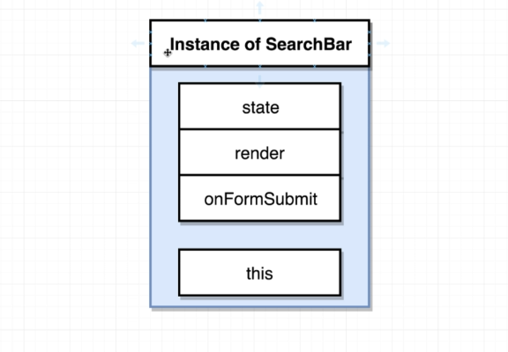

This can be used to access class functions and vars ie state object inside the class. But, this.state is valid but inside a function? 🡪

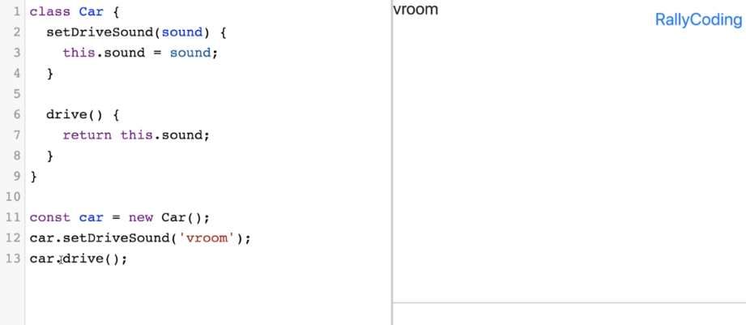

Here in drive() this means the car object which is calling the drive method.

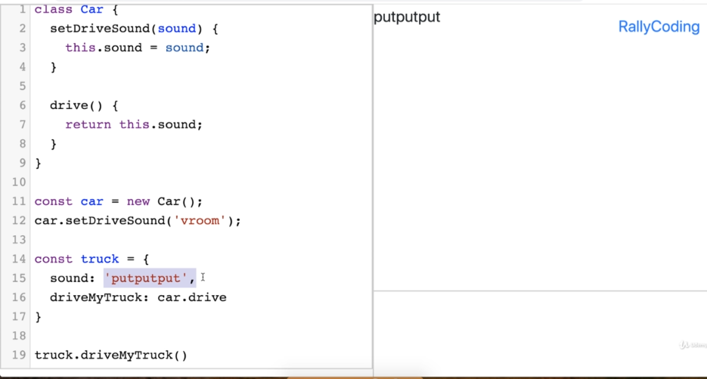

Here this means truck object.

To solve this always use arrow function 🡪

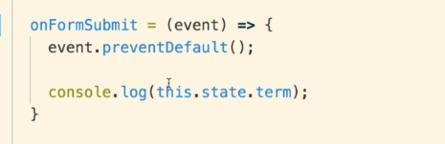

Another way is 🡪

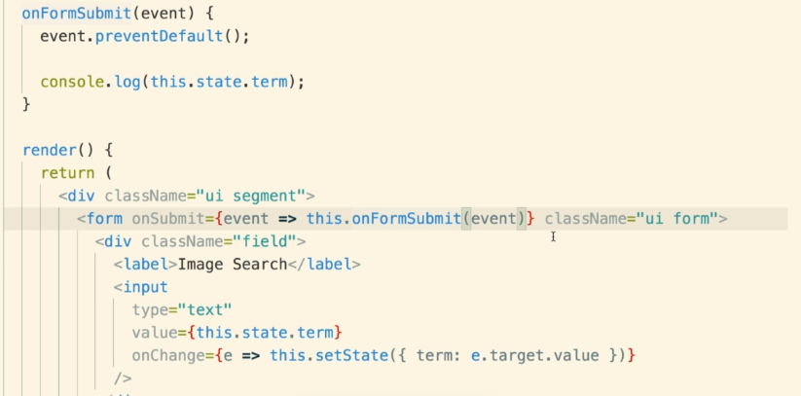

Now we have created the searchbar and now we want to search for the word.

We will use the API in the app component and we will pass the keyword from our component to the app component.

Child Component 🡪 Parent Component (props system does not allow it)

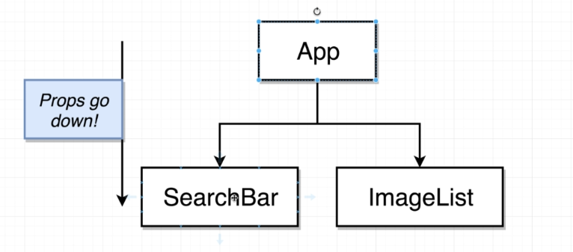

We will do 🡪

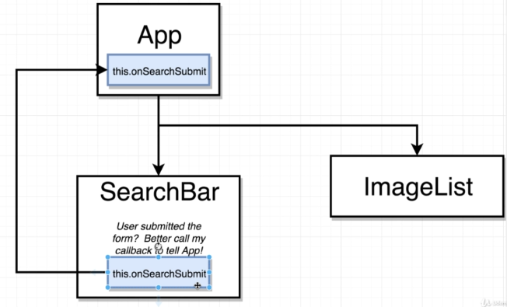

We refactored our App component as class 🡪

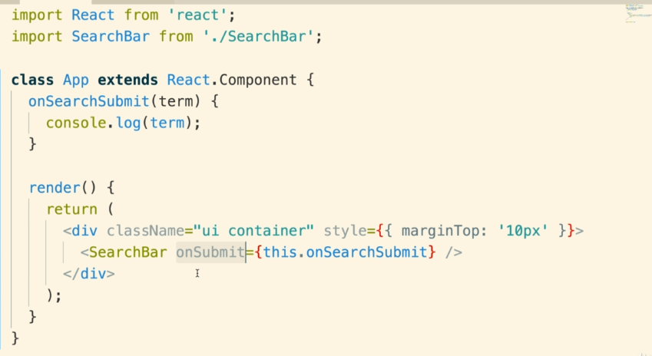

Notice that we are passing a function as a prop to the child component ie SearchBar.

Note: onSubmit is arbitrary ie instead of it, It can be anything.

We will modify SearchBar component as 🡪

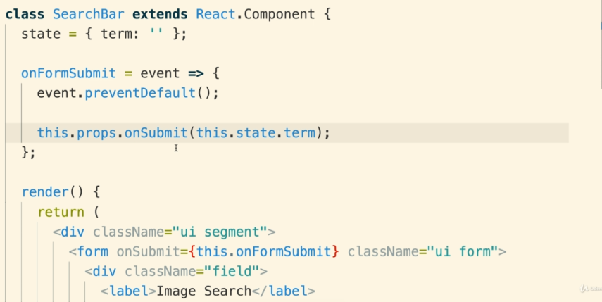

Here we are using the props which was passed by some parent component.

We are calling the function which was passed and we are passing term.

Using an API to fetch data 🡪

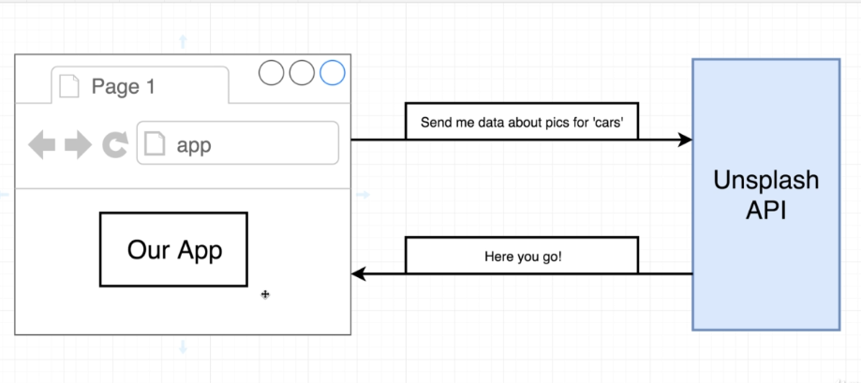

We will use unsplash api to get data.

How API will work 🡪

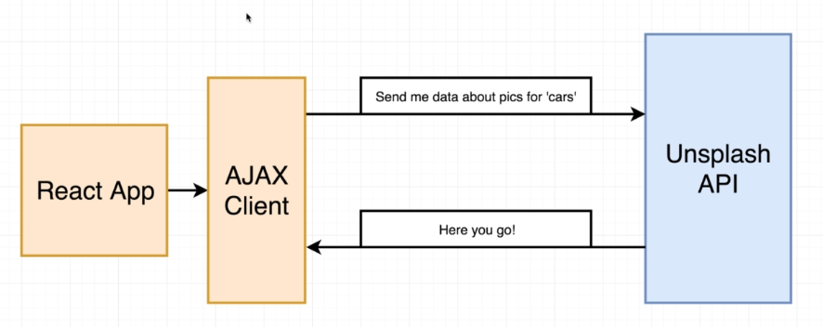

Two Ways –>

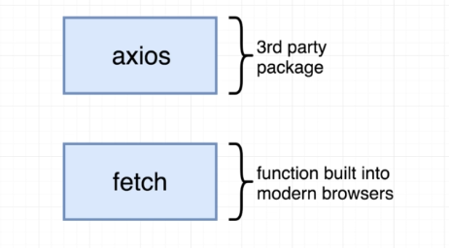

Fetch is basic and lower level.

Axios is higher level and we need to write less code than fetch.

We will use axios.

Making a request using axios 🡪

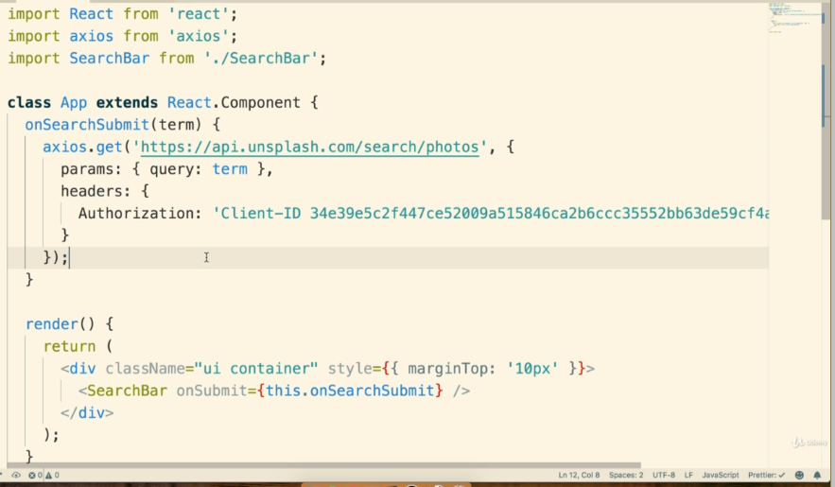

Axios.get(‘The API URL’, {Object with params and header})

onSearchSubmit(term){

        axios.get('https://api.unsplash.com/search/photos',

        {

         params: {query: term},

         headers: {

            Authorization: 'Client-ID AxG__ZCOf5MJ7awJWMV5Qf7MterQZc-NXNZ8P8BmPsM'

          }

        })

    }

Params 🡪 all the params you want to pass.

Query:Term 🡪 thing we want to search for

Header: required header information for the API request.

How to show images on the screen 🡪

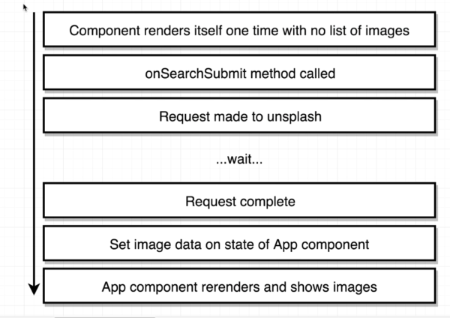

First, we will just try to print the number of pictures fetched on the screen in the app component.

Also, network requests are async request. So, when the API request is complete and we have fetched the data then we want to get a notification.

For that there are two methods 🡪 First 🡪

First of all we need to know that whenever we call an API using axios, it will always return a promise. So, we can chain and enter then() here.

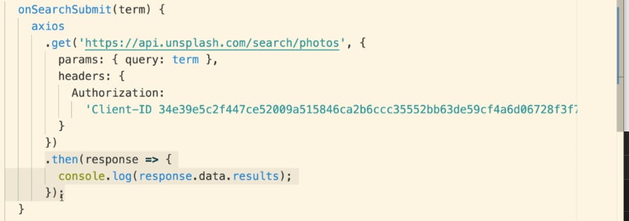

Second 🡪

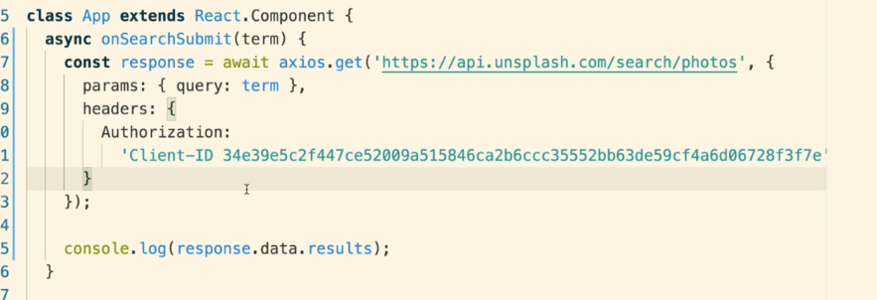

Use the keyword async - await.

Use Async before the function which is asynchronous and you want to execute by altering the flow of the code.

Use await where you want to make sure that code gets executed in sync.

As shown in the image.

Whenever we expect our state property to have an array of objects, we will do 🡪

state = { images: [] }

Here is the final code 🡪

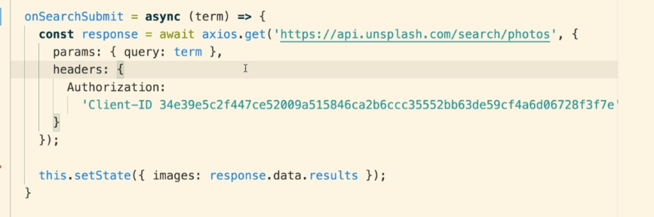

Here images is an array and it contains all the objects that are returned.

To print the no of objects returned 🡪

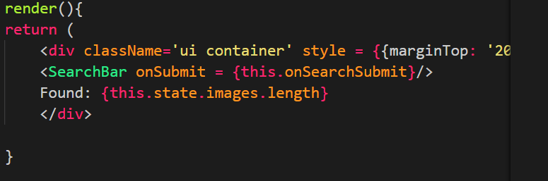

The code for onSearchSubmit function is bit complicated. We can make it easy by create a folder API and inside we will create unsplash.js 🡪

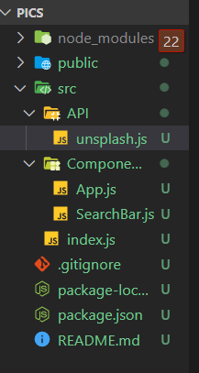

Inside this .js file we will do the configuration and make code in onSearchSubmit easier 🡪

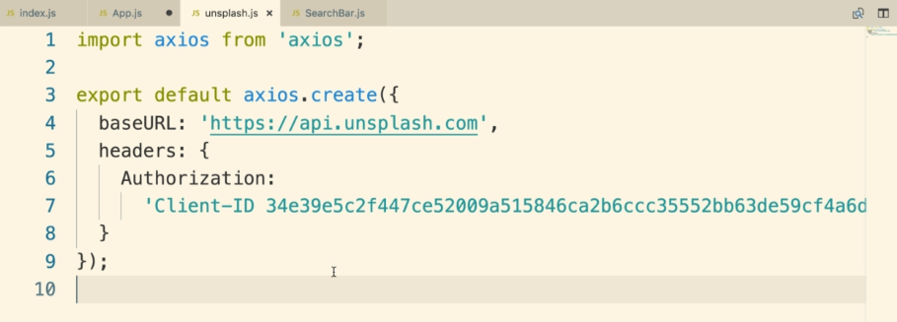

onSearchSubmit looks like this 🡪

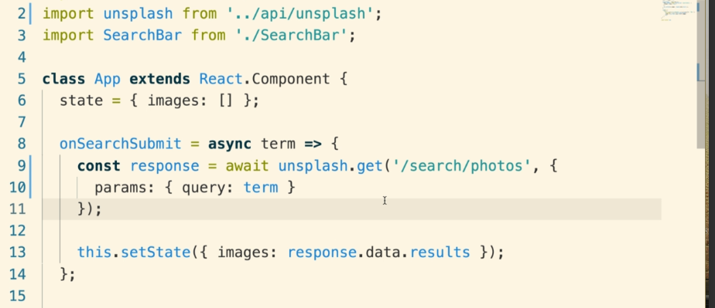

We imported unsplash.js from API folder.

Then we called get method there.

We will now try to create a ImageList Component to show our list of images 🡪

Here, we will pass image list from app component to our ImageList component.

Here is information about map function in JS 🡪

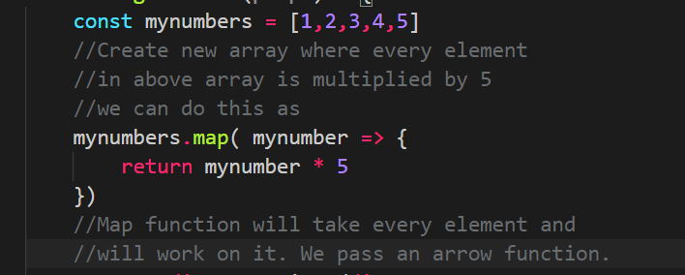

This is the ImageList Component 🡪

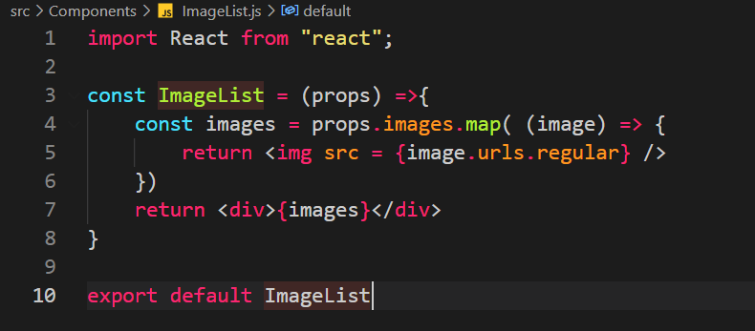

Render method in App component 🡪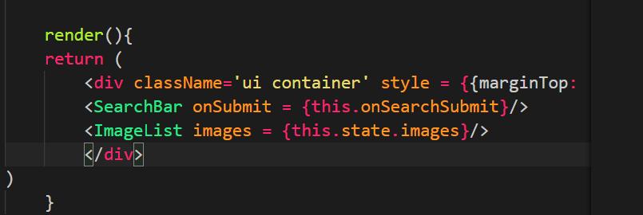

But we get the following warning in the chrome 🡪

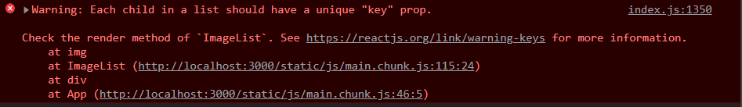

Below is an example to understand this 🡪

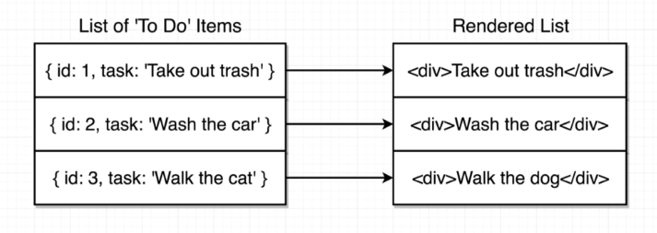

But if user enters a new task after some time, then 🡪

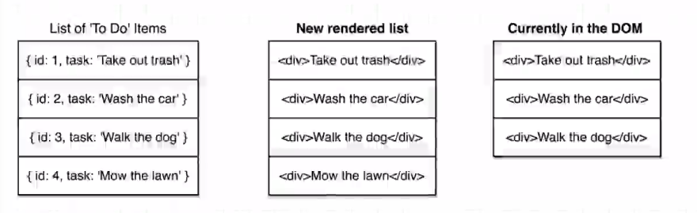

We need to rerender the list here. Here react will see that take out trash item is already in the DOM so it does not need to put it there again so It can be passed. Similar for next also.

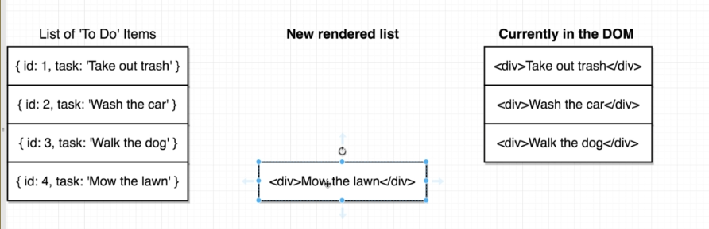

Now for last item update is needed in DOM. Now if we want that then we need to add a key prop to the items.

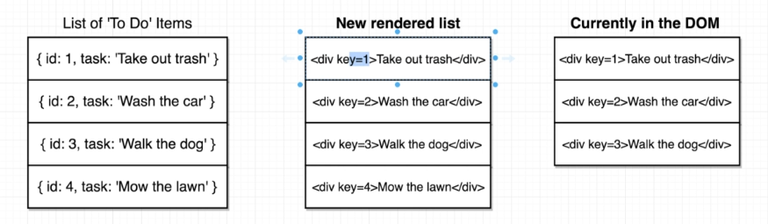

Only key = 4 needs to be updated in DOM.

**It is very important for PERFORMANCE of the app.**

Here is updated ImageList Component 🡪

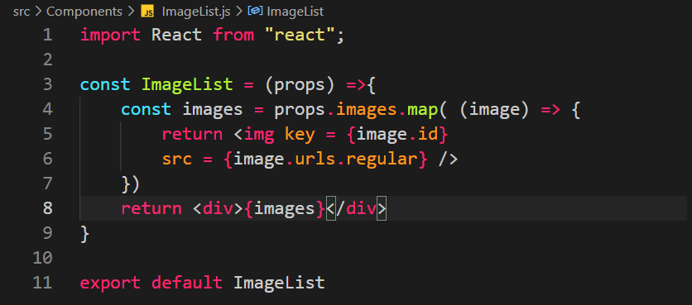

Image.id is used because id is returned to us by the API.

**Remember that key prop will always be attached to the root element that is being return by the component. Look at the example below 🡪**

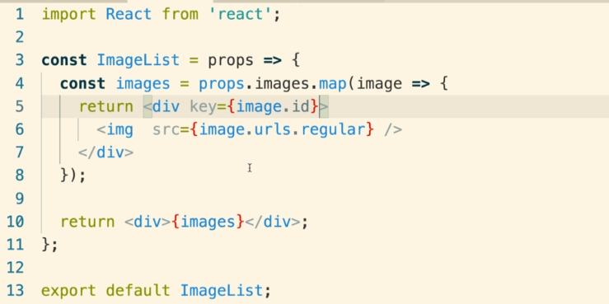

**Here <div> is the root element.**

We can do some reduction in code by doing this 🡪

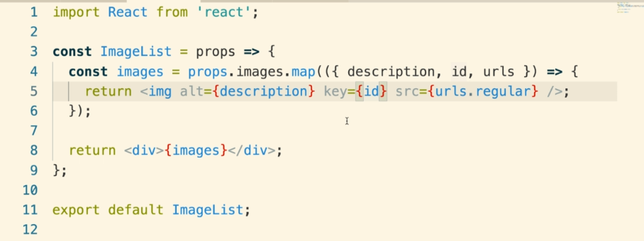

Here is a list of elements in React 🡪

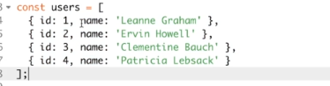

We will show it in list tags 🡪

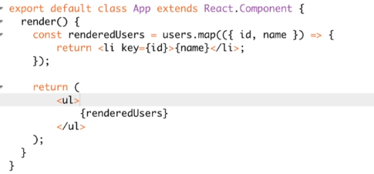

We have created our list and we are showing big images but we want small and grid of images. Here is what we have 🡪

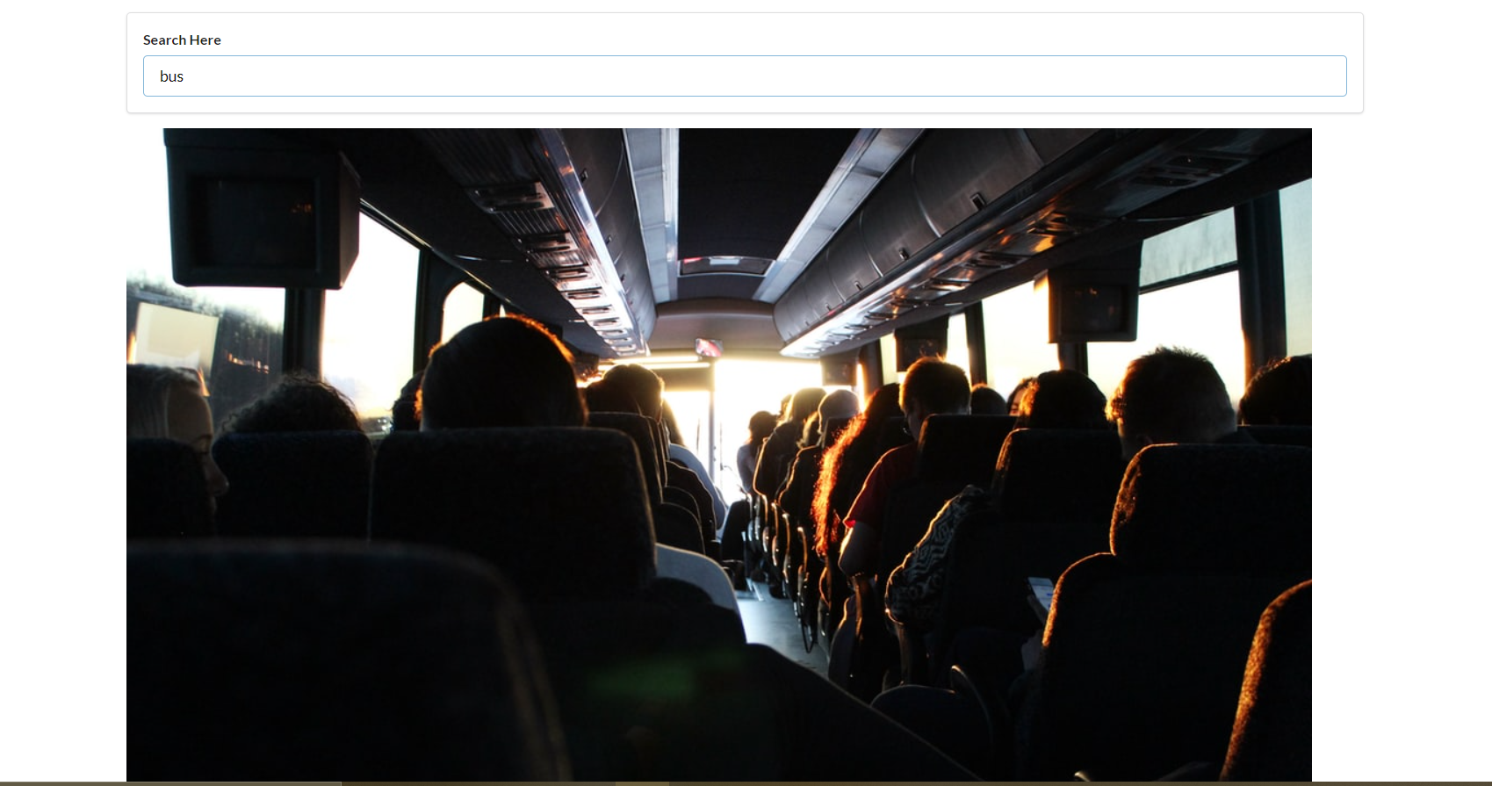

We can do this for grid 🡪

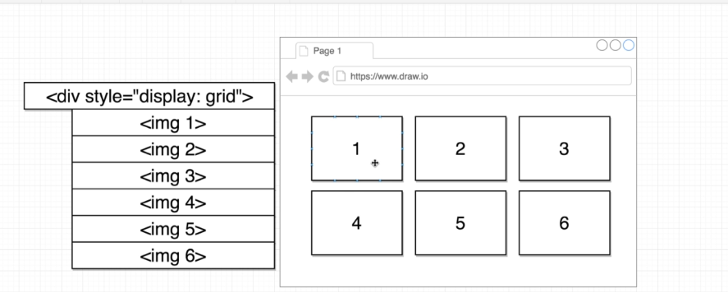

What we will do to solve this is to just create a new component and in that component, we will take every image and then decide what its dimensions are then we will show it according to that. ImageCard.js 🡪

So, basic ImageCard component looks like this 🡪

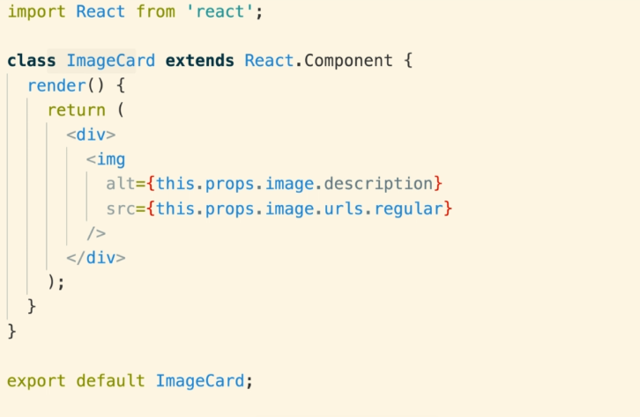

We can also destructor and make it like 🡪

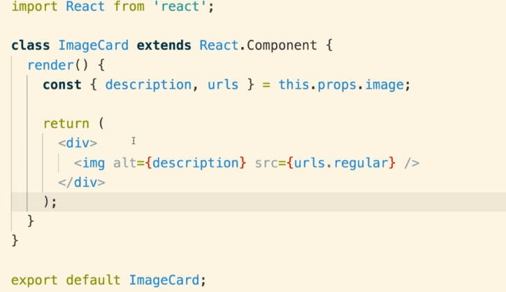

And ImageList Component now looks like this 🡪

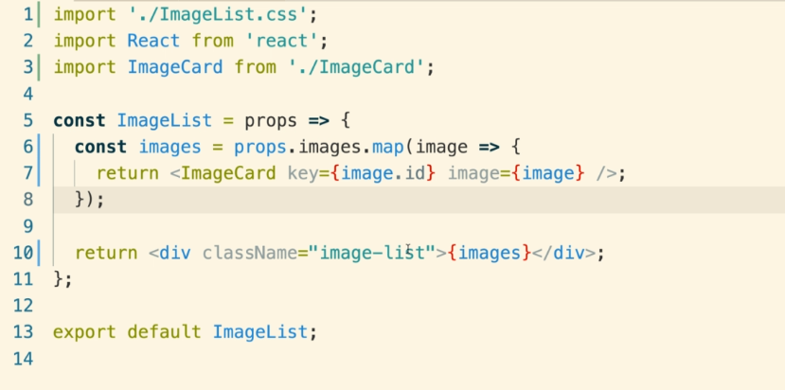

Now we will do this 🡪

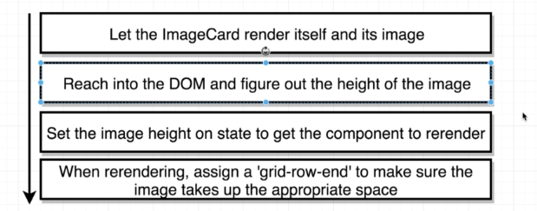

We want to get height by reaching the DOM, we can do this is tradition JS as 🡪

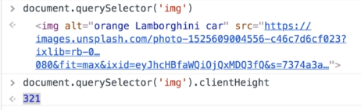

In react we use 🡪

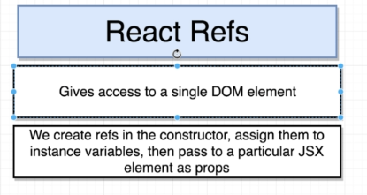

We can attach ref as 🡪

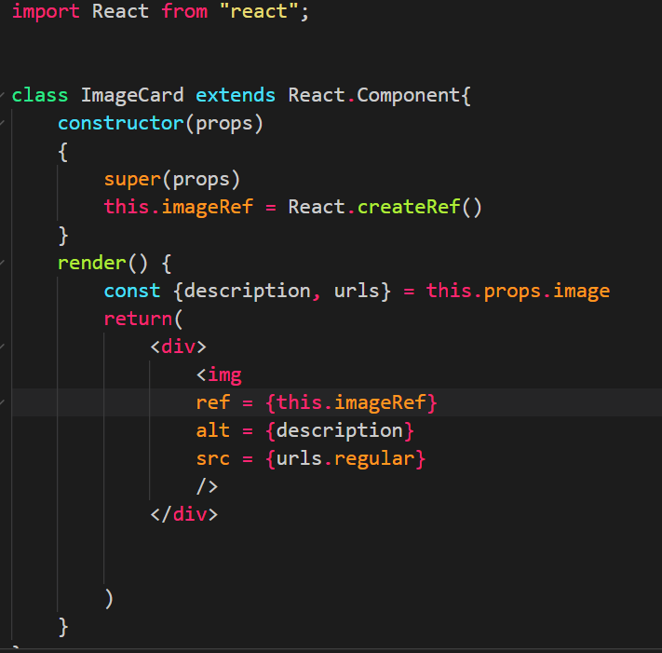

## Hooks in React 🡪

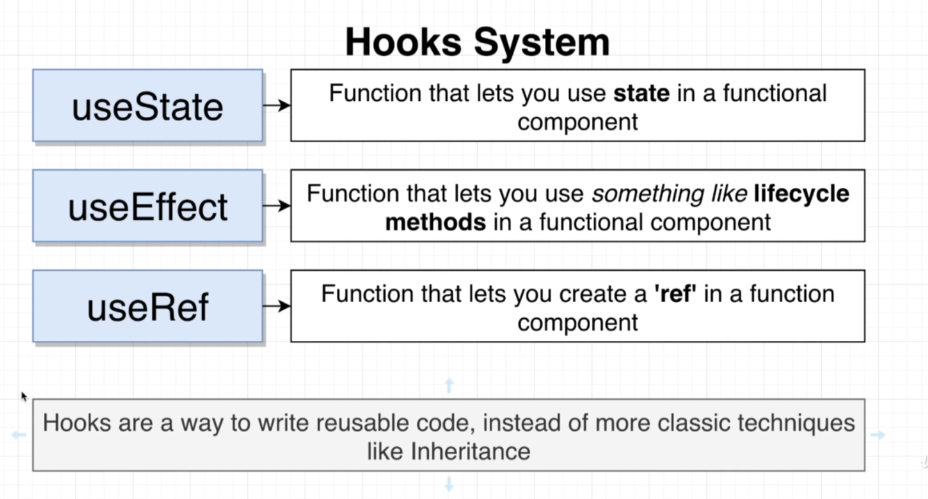

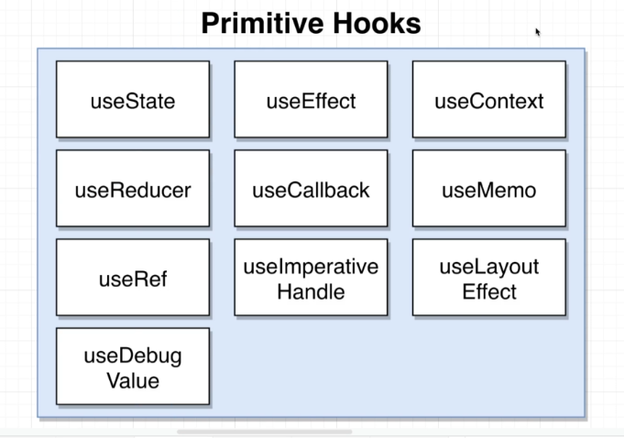

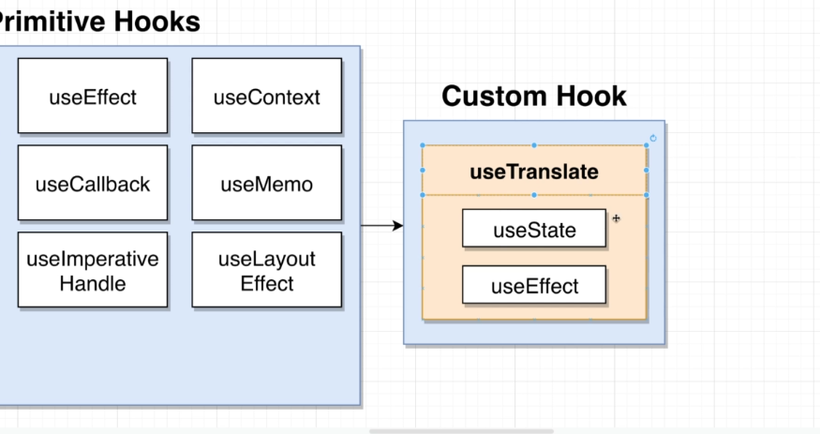

Our App Architecture 🡪

We want to create an app like this 🡪

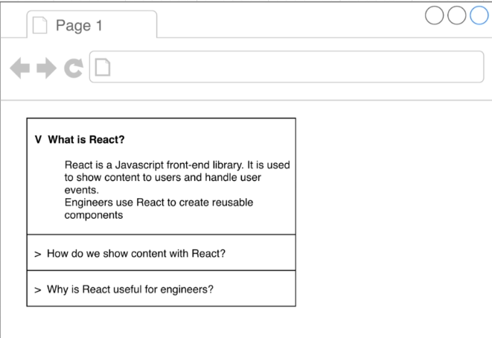

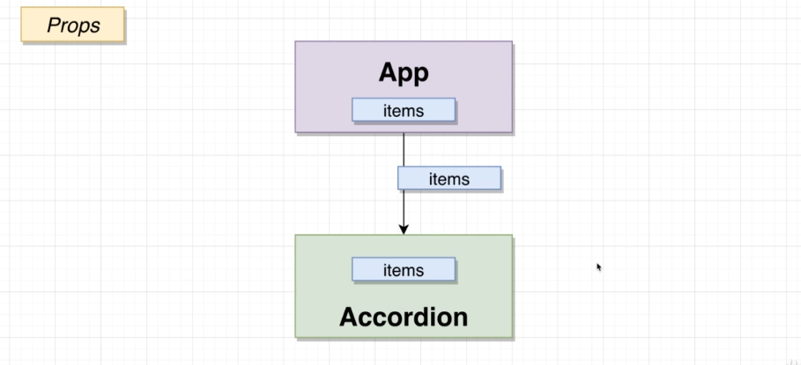

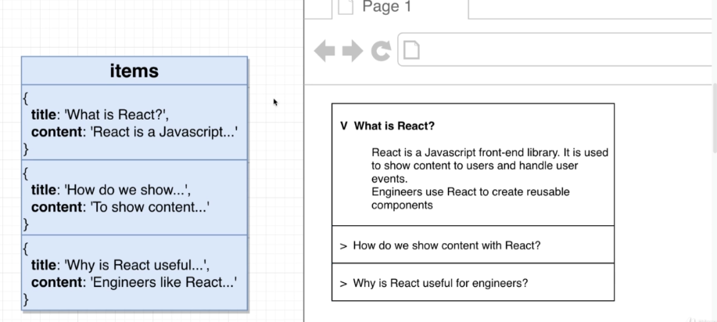

Title and content will be props here.

State here will be the question which is expanded.

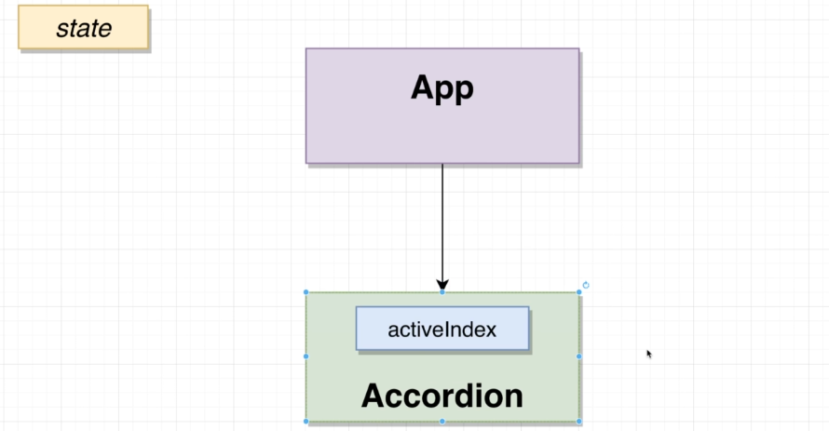

Accordion component so far 🡪

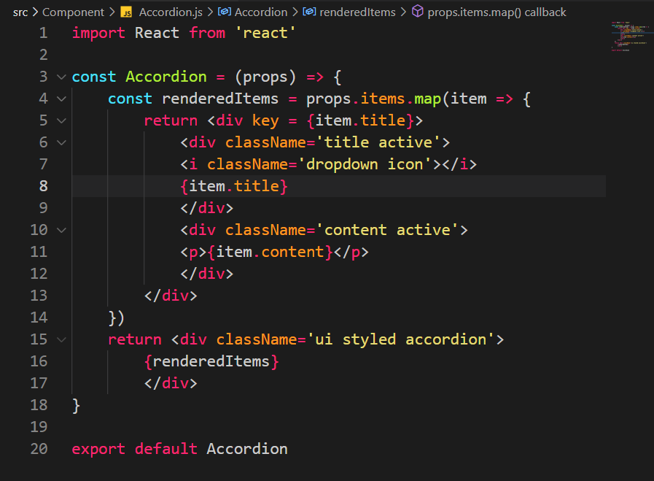

App Component so far 🡪

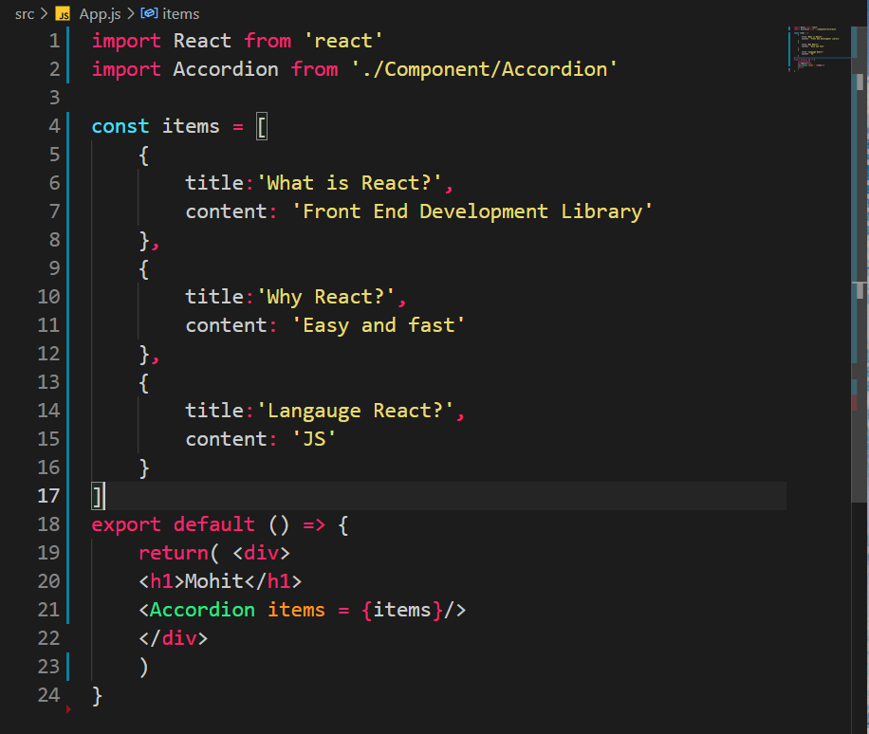

Result so far 🡪

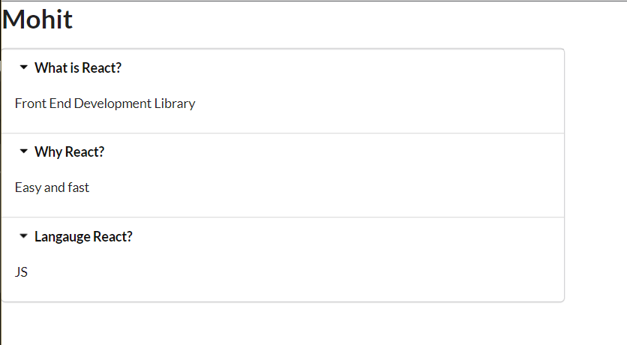

Write helper functions as given 🡪

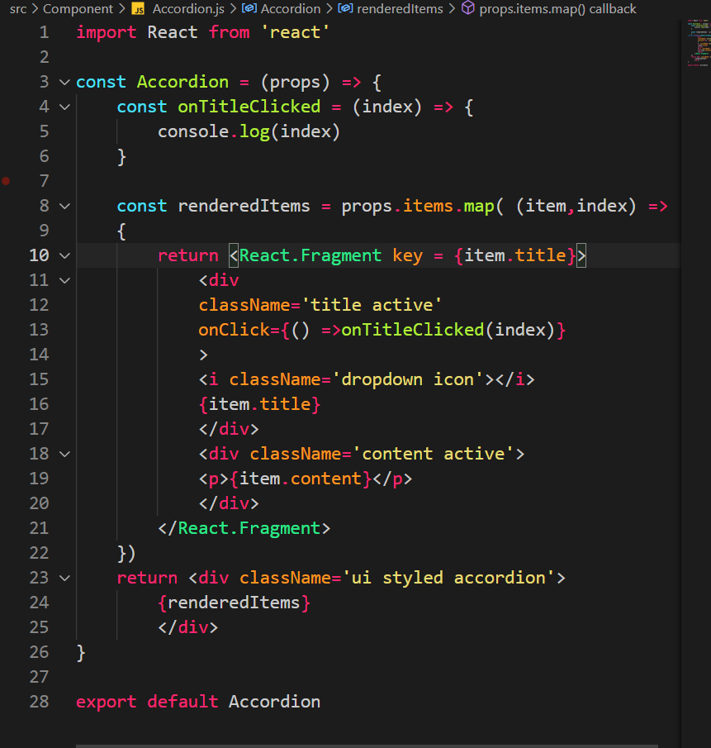

useState hook 🡪

import React, {useState} from 'react'

**How to declare 🡪**

const [activeIndex, setActiveIndex] = useState(null)

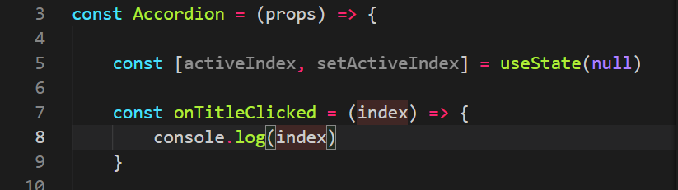

Here activeIndex is the name of the state variable and setActiveState is the function that will be used to modify the state. useState is a function that is the hook and null is the initial value of the state.

**Remember: Whenever the value of the state changes the component is re-rendered.**

To modify the state 🡪

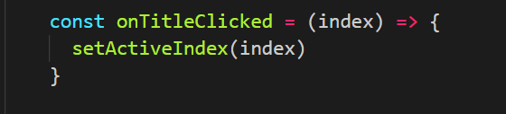

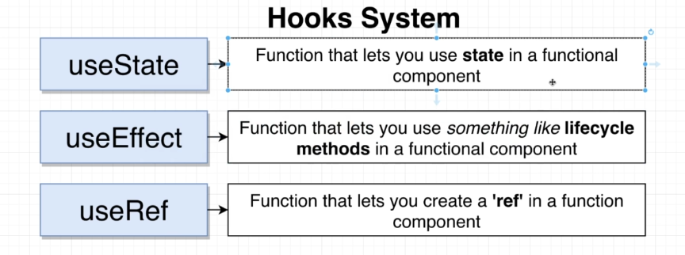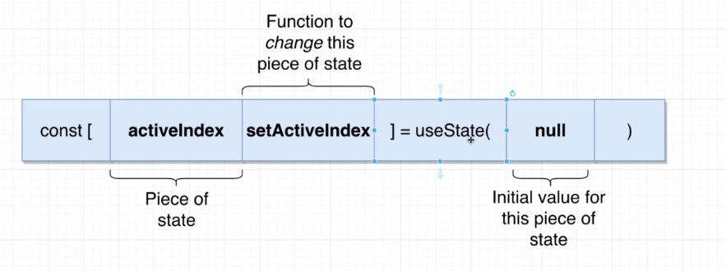

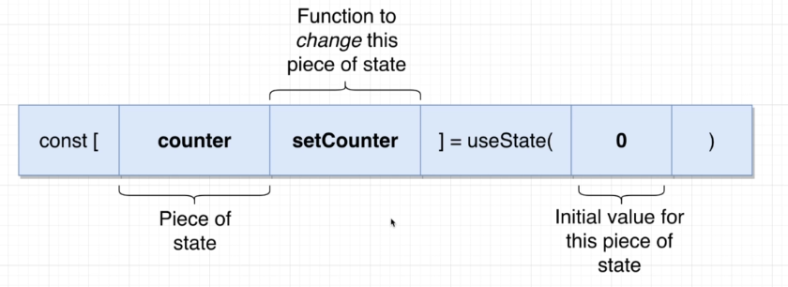 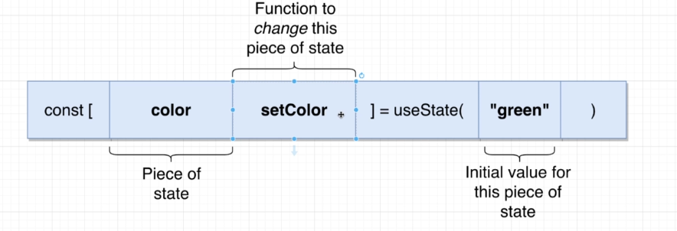

State in Class vs State in Function 🡪

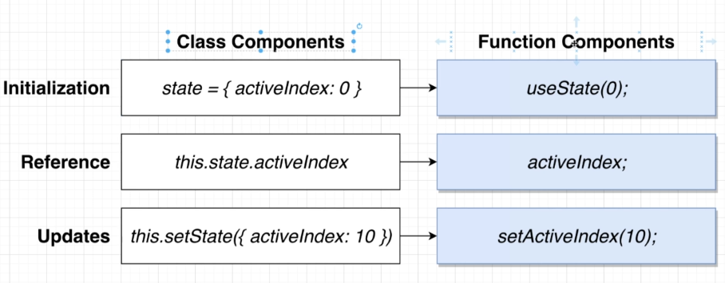

For multiple states 🡪

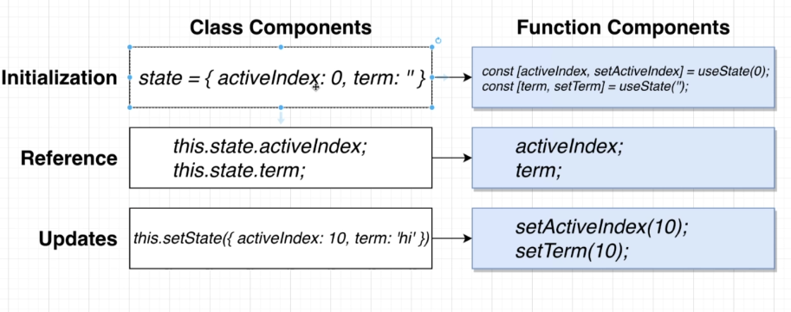

**Example of a simple counter using hooks 🡪**

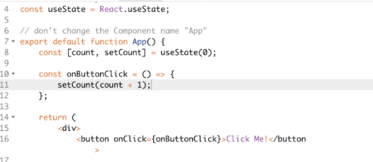

We are trying to create an application like this 🡪

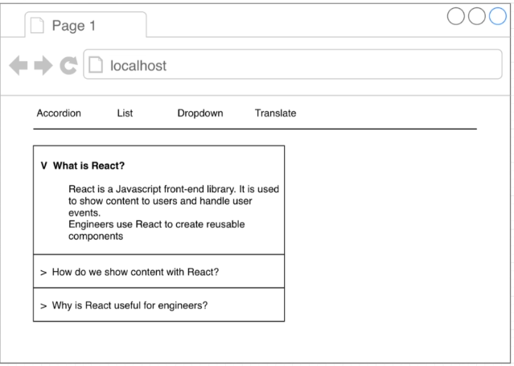 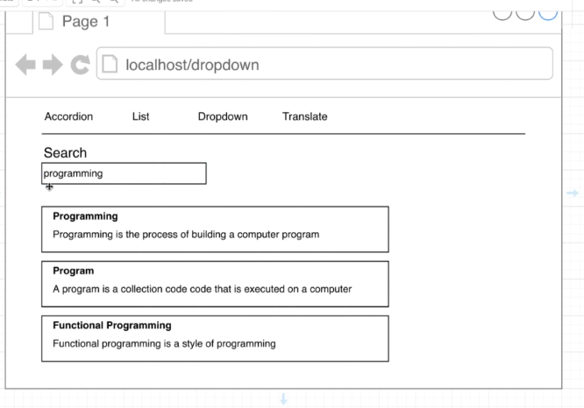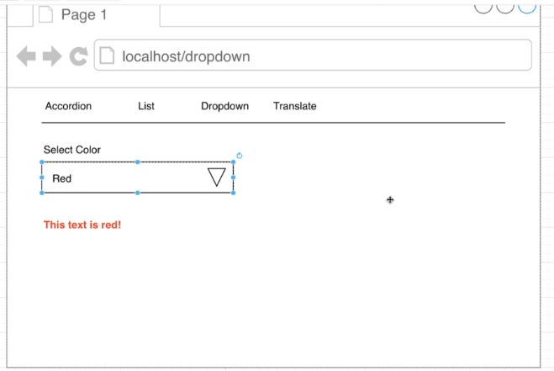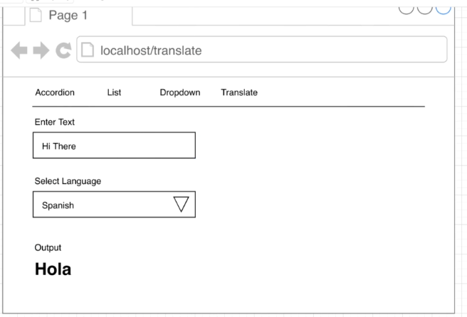

Four Pages/widgets we want to create and we will put them together using some navigation.

Lets create this 🡪

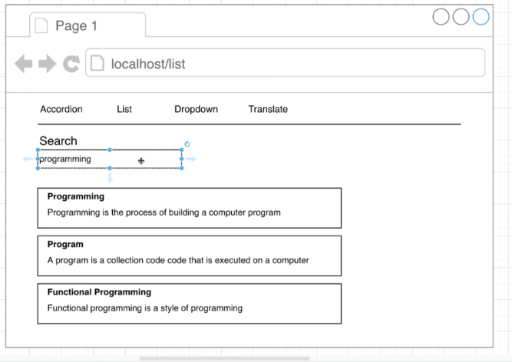

We will use 🡪

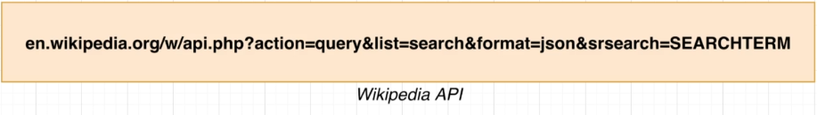

From this API we get 🡪

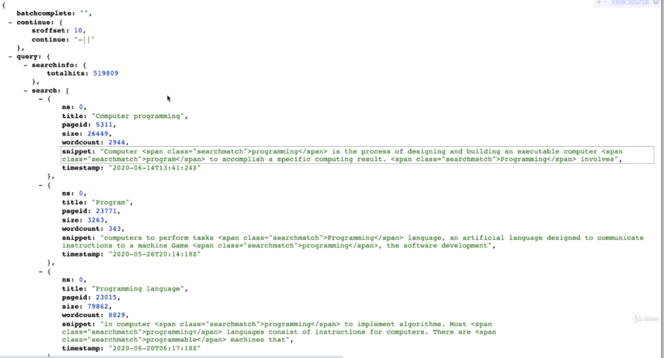

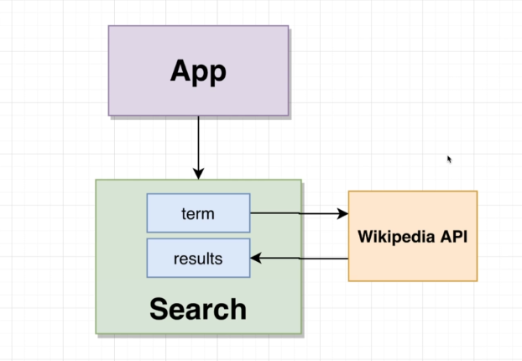

Here we will write a search term and then search it via the wiki API and show the result.

How we will proceed here 🡪

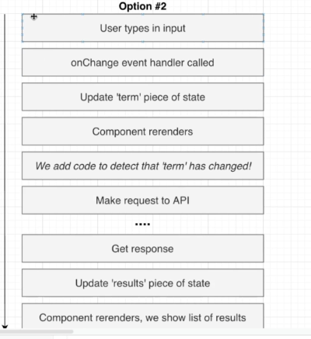

useEffect() hooks 🡪

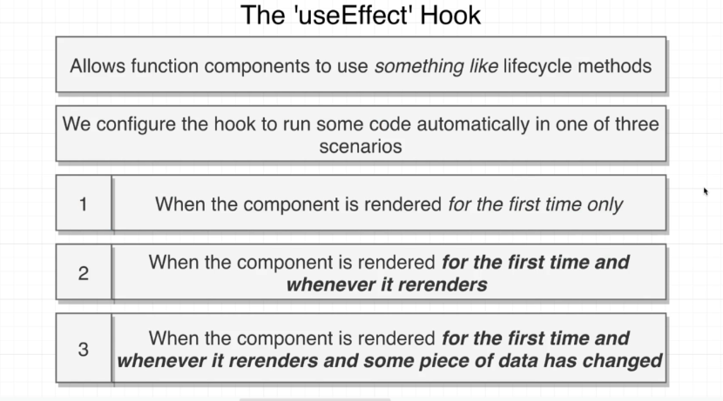

Used instead of componentDidMount() componentDidUpdate() .

useEffect() takes two arguments, first one is an arrow function which will have the code to be executed and the second one will tell us which one of the three conditions(in the above diagram) is being used for useEffect.

1. No second argument 🡪

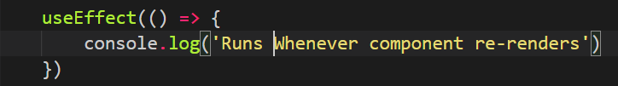

1. Empty array as second argument 🡪

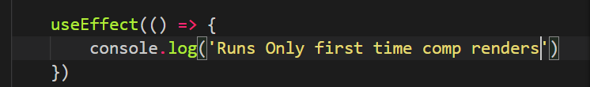

1. Second argument with one or more terms 🡪

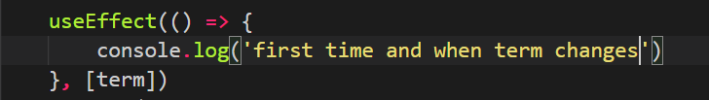

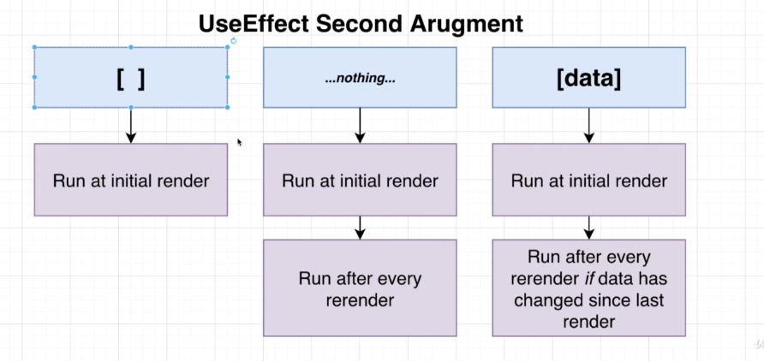

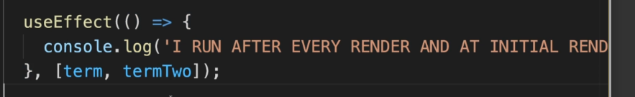

**Note: In this case if any of the term ie either term or termtwo changes and the component re-renders then the useEffect will run.**

One cautionary thing about useEffect is that we cannot mark the () function we are passing as async and then use await inside that function. Not allowed wih useEffect()

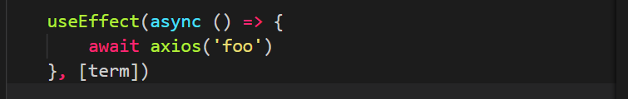

Above image code is not allowed.

We can get around this using this 🡪

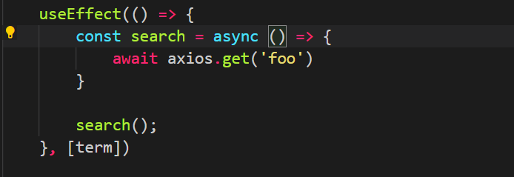

Create a new method and mark that async and use await inside that. After that we call that method.

But we do this as well 🡪

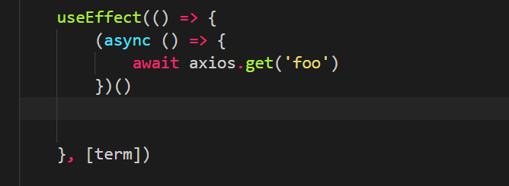

Here we are declaring and calling the function at the same time.

We can also do 🡪

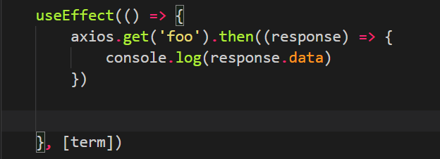

XSS attack in React 🡪

XSS Attack 🡪

Cross-Site Scripting (XSS) attacks are a type of injection, in which malicious scripts are injected into otherwise benign and trusted websites. XSS attacks occur when an attacker uses a web application to send malicious code, generally in the form of a browser side script, to a different end user. Flaws that allow these attacks to succeed are quite widespread and occur anywhere a web application uses input from a user within the output it generates without validating or encoding it

In react we have 🡪



By doing this we will render the string result.snippet as html code and not like a normal string.

Before we had this 🡪

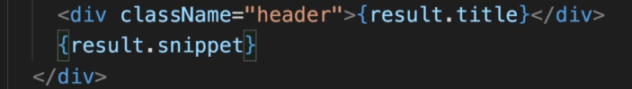

Here the result.snippet will be treated as a normal string and not as html code.

We changed from below to above.

Till now what is happening is that whenever we write any keyword a search happens on the wiki API which is a lot and is slowing down our process.

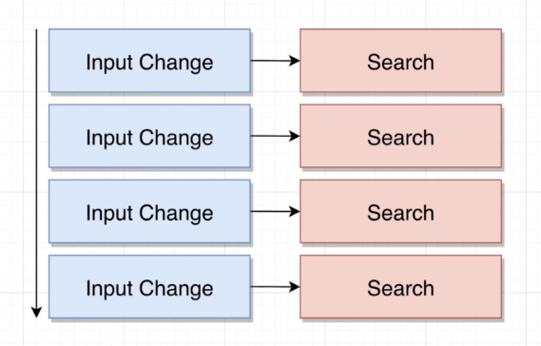

We will implement this 🡪

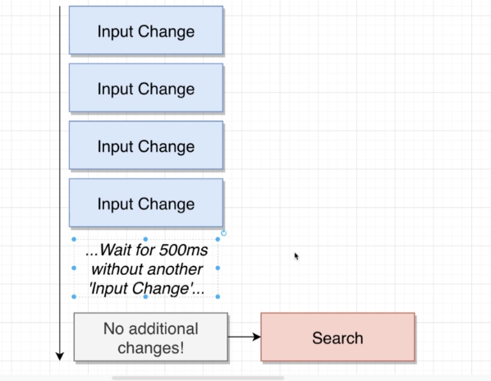

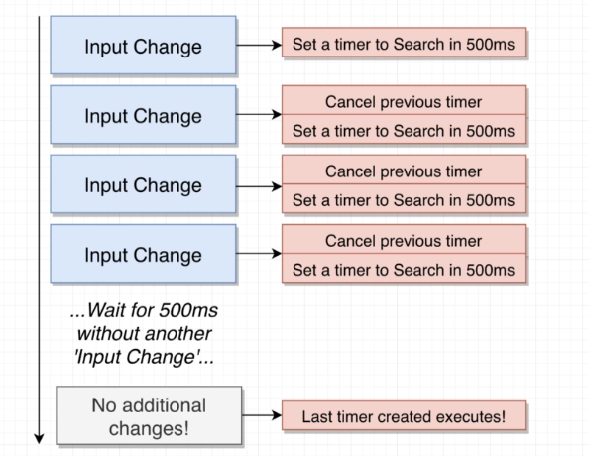

We will use the setTimeout function of JS for this. We will use clearTimeout() for stopping the timer and resetting it.

Some points about useEffect() 🡪

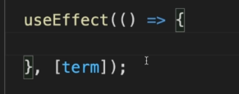

**Note: term here is a state variable.**

Above function executes:

1. When component is first rendered.
2. When term state changes
3. It does not run when any other state variable changes.

We can only return a function from useEffect function. 🡪

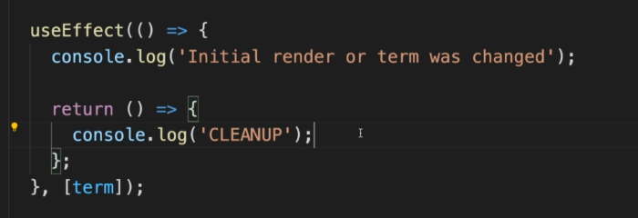

This is used to clean-up.

This will be called automatically in the future.

The clean-up functions runs 🡪

1. When the component is first rendered then all the code in the useEffect will run and the clean-up function is returned but not called, so code in the clean function will not be executed in the first render.
2. When the useEffect is called again then first the clean-up function is called then the code of the useEffect will run.
3. After this every time clean-up function is called after that we executed the arrow function ie the code of useEffect()

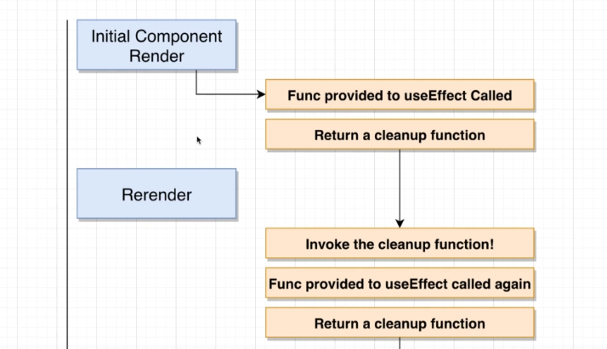

Code in **Search.js (Search Component) 🡪**

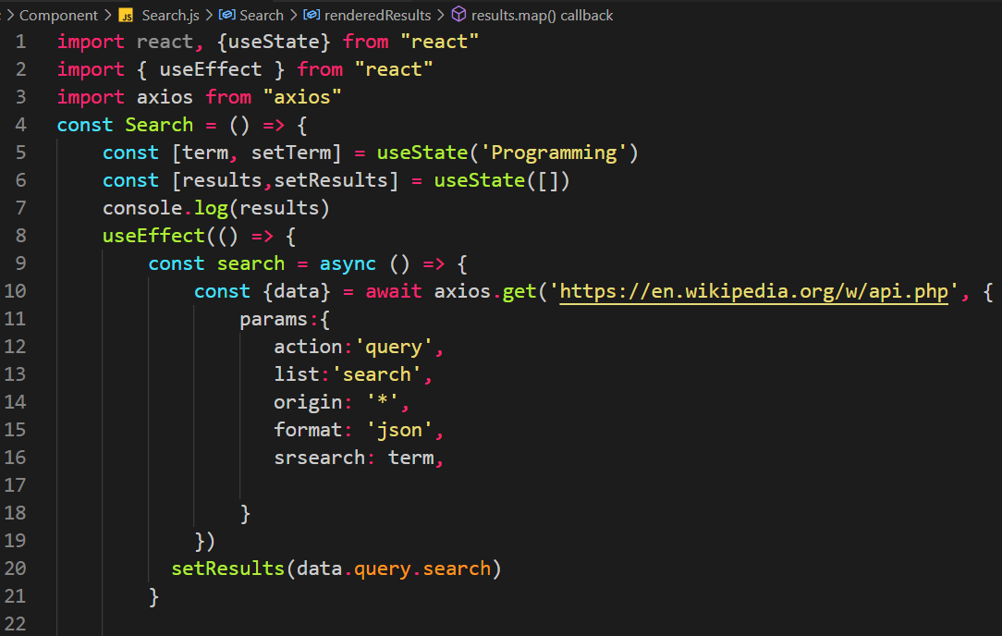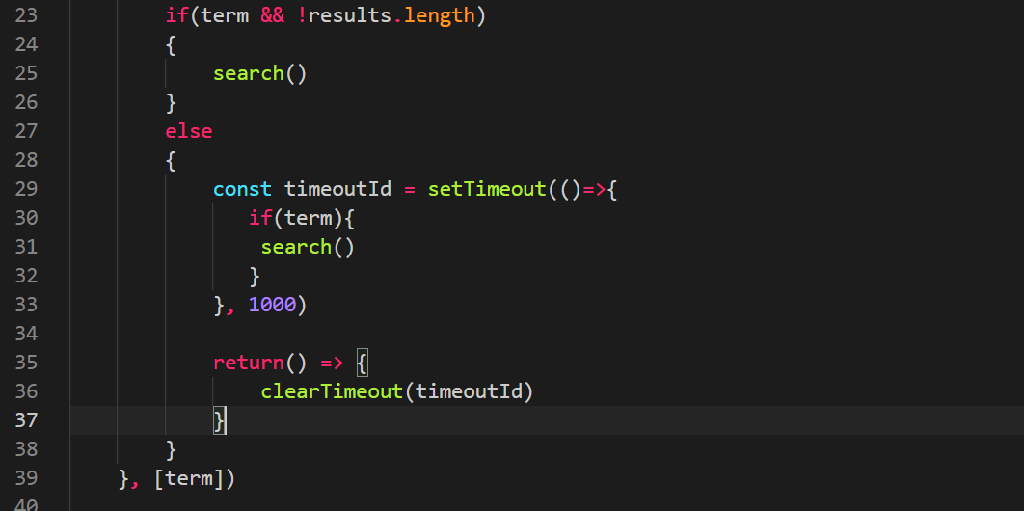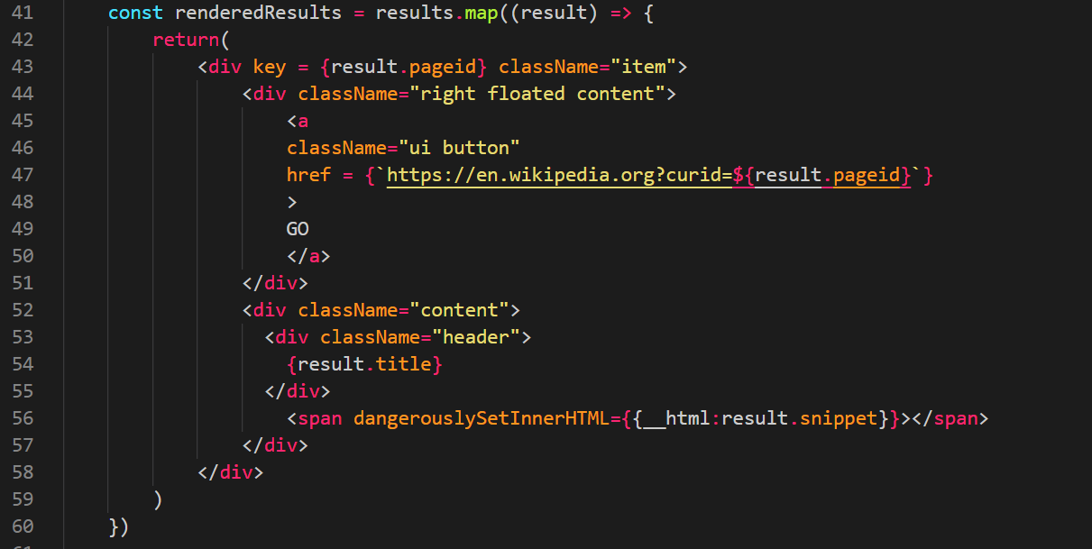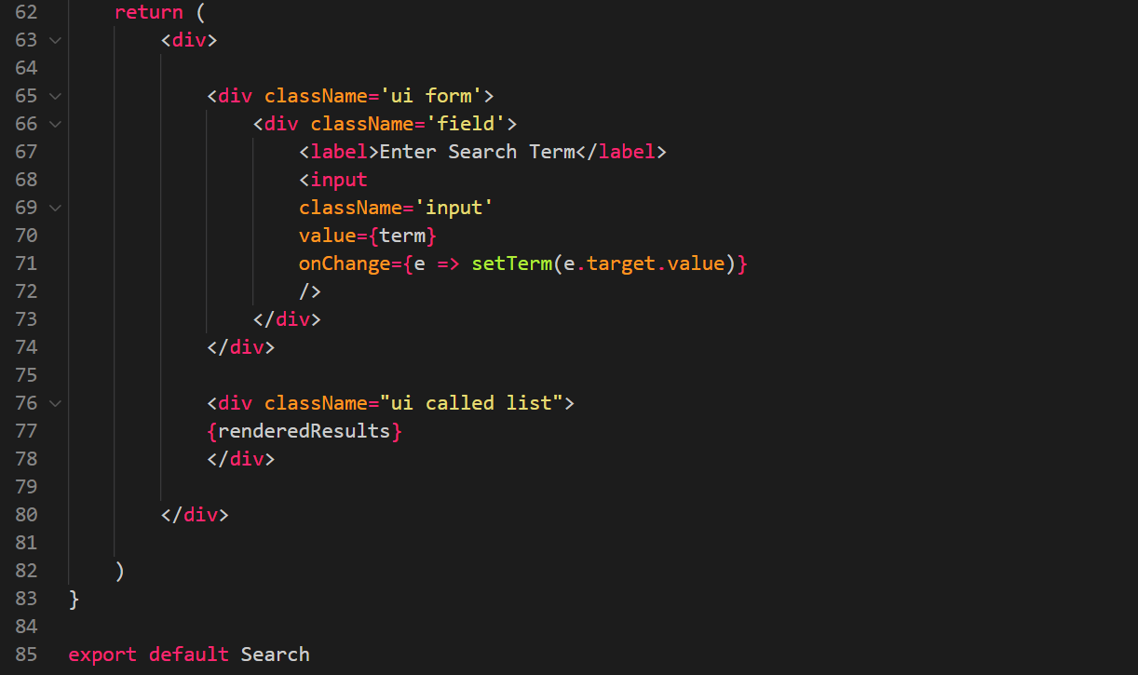

**File 🡪**



Lets create this 🡪

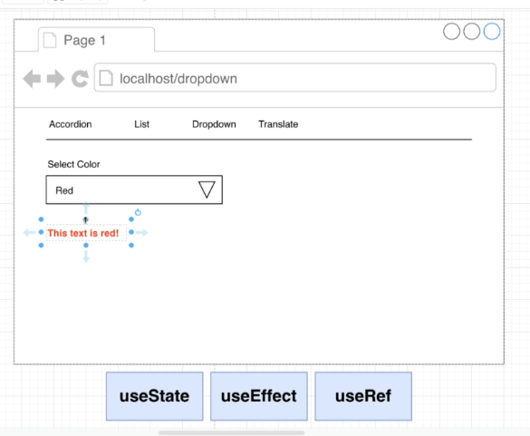

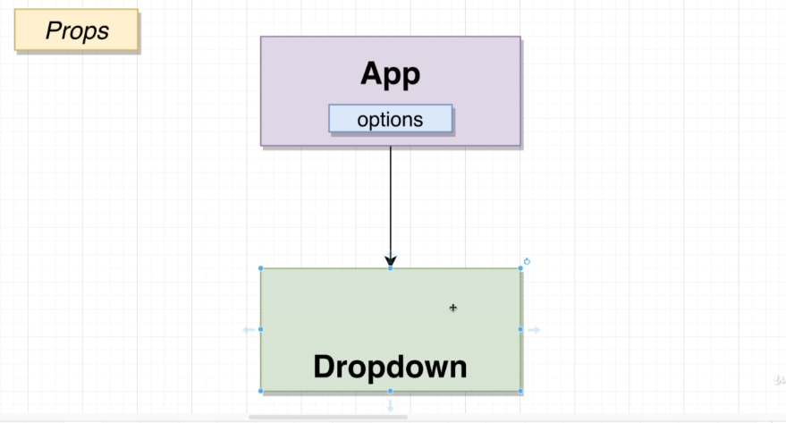

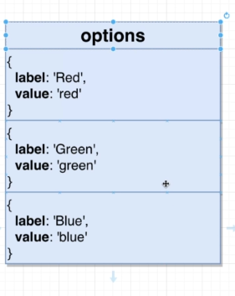

Label and value are different here. Label gets displayed and value is what we use in code.

State:

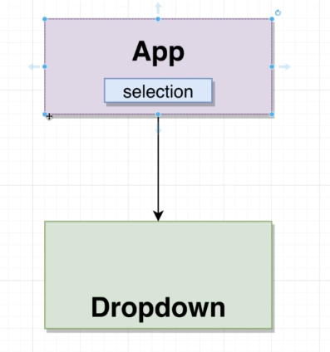

Select will tell us what color has been selected by the user.

We will create the select state in out App component bc we may use the dropdown multiple times 🡪

Options array in App component which has the list of values that can be selected 🡪

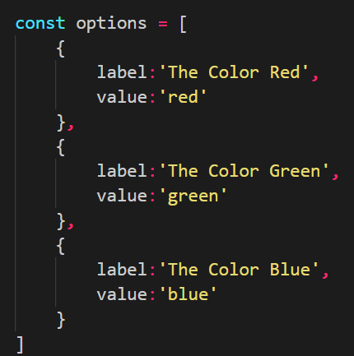

State 🡪



Passing State and Props to Dropdown component from app 🡪

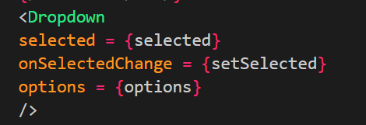

Here is the list 🡪

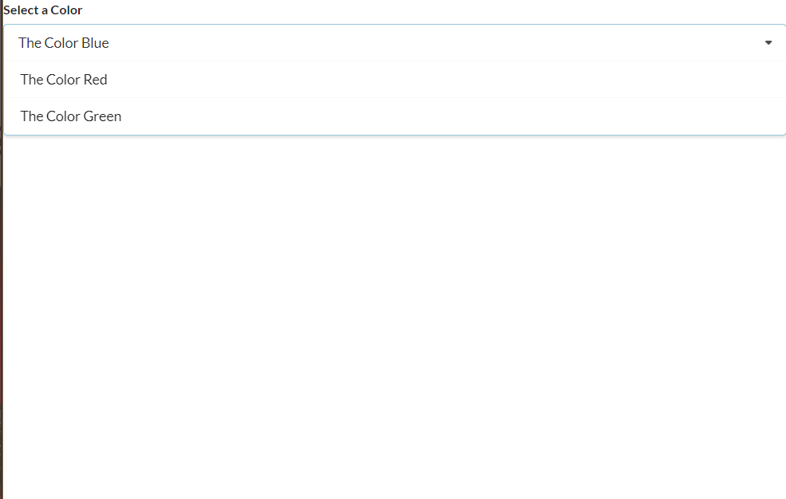

What I want now is that when I click anywhere outside the dropdown the dropdown should close. This is actually complicated bc for out dropdown component it very hard to get to know when the user clicks outside the dropdown component.

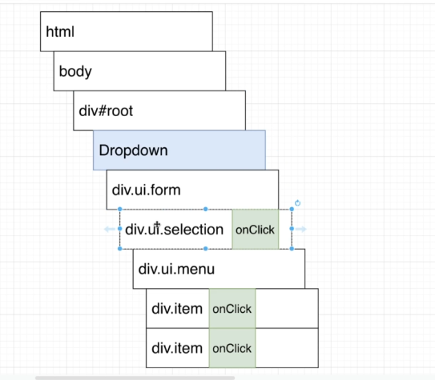

This is the Drop down structurally.

Even bubbling 🡪

When user will click on an item in the list 🡪

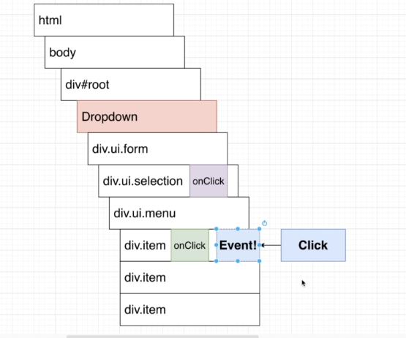

Even is generated by item and then this event will travel up to the next element above ie menu. 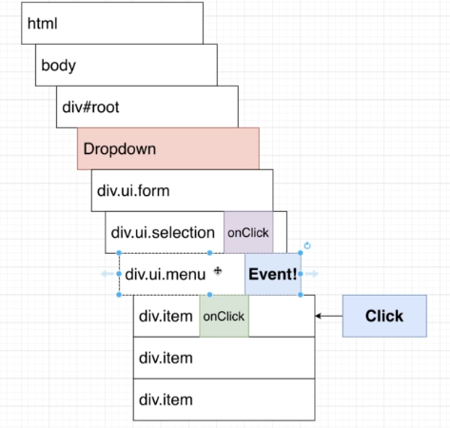

Then it will go to next one above and if the above element has a onclick event then that will be invoked.

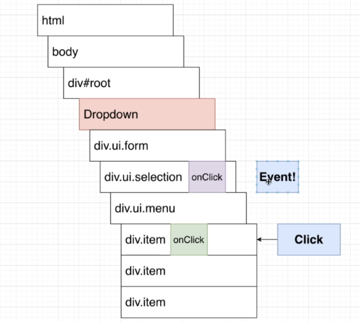

Here selection also has onClick event so now that is also fired.

And it will go to the next element above and so on…

Eg we have the below function 🡪

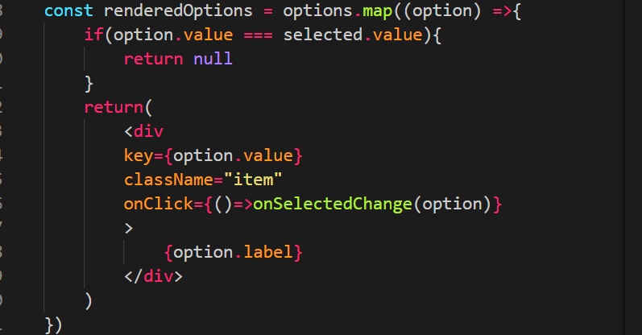

This displays the list of drop down items and will update the state when a different item is selected. But when a different item is selected drop down closed automatically. This is because we have 🡪

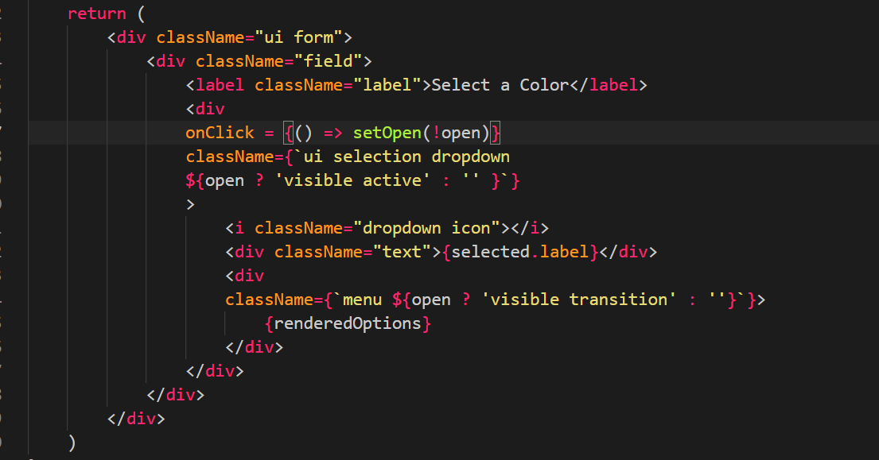

Here we have that list renderedOptions and when on click happens for a menu item and we will go up to the next element and check if it has a onClick element or not. Here we have on click on one of the divs above, so that onClick is also called and bc of that the dropdown closes.

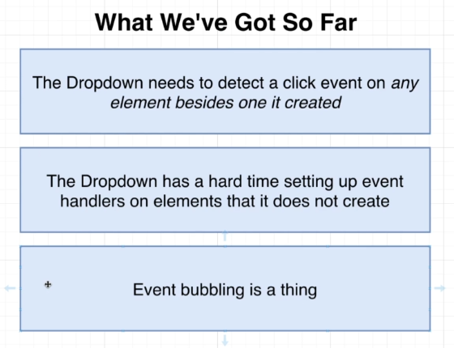

Solution 🡪

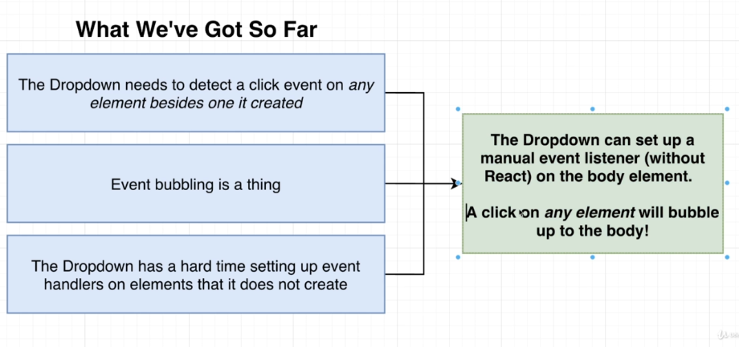

We have two scenarios 🡪

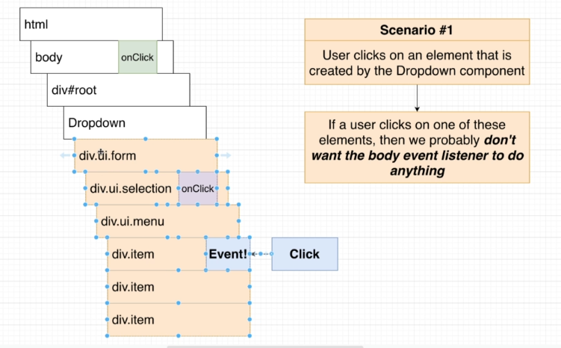

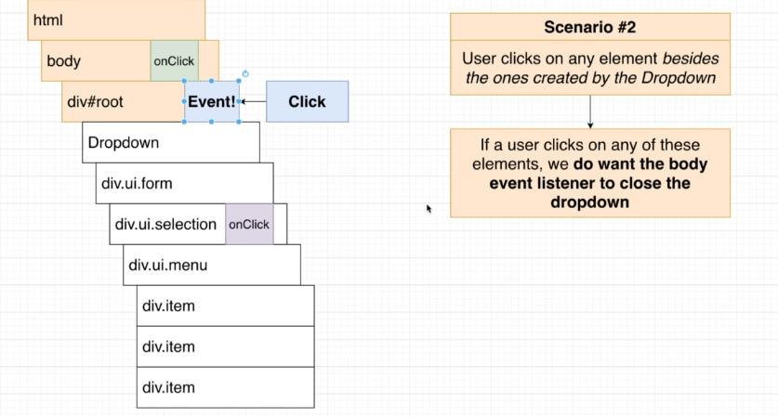

useRef() hook 🡪

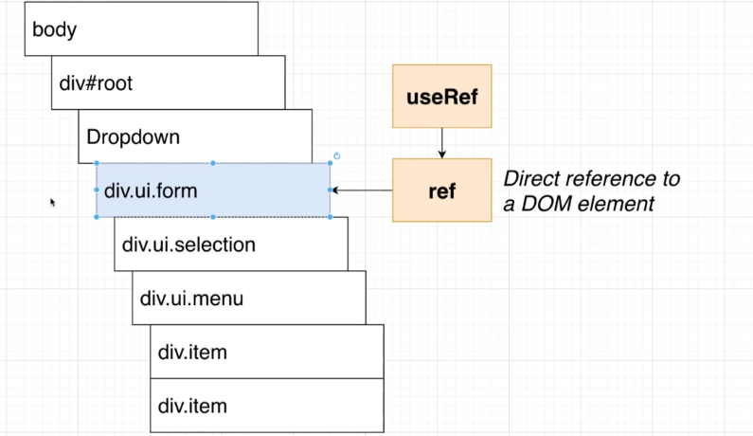

We need to import 🡪



Creating a ref 🡪



Assigning a ref 🡪

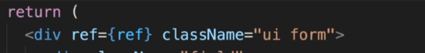

The **useRef** Hook allows you to persist values between renders.

It can be used to store a mutable value that does not cause a re-render when updated. It can be used to access a DOM element directly.

## **Does Not Cause Re-renders**

If we tried to count how many times our application renders using the **useState** Hook, we would be caught in an infinite loop since this Hook itself causes a re-render.

To avoid this, we can use the **useRef** Hook.

Use useRef to track application renders.

import { useState, useEffect, useRef } from "react";

import ReactDOM from "react-dom";

function App() {

const [inputValue, setInputValue] = useState("");

const count = useRef(0);

useEffect(() => {

count.current = count.current + 1;

});

return (

<>

<input

type="text"

value={inputValue}

onChange={(e) => setInputValue(e.target.value)}

/>

<h1>Render Count: {count.current}</h1>

</>

);

}

ReactDOM.render(<App />, document.getElementById('root'));

## **Accessing DOM Elements**

In general, we want to let React handle all DOM manipulation.

But there are some instances where useRef can be used without causing issues.

In React, we can add a ref attribute to an element to access it directly in the DOM.

### **Example:**

Use useRef to focus the input:

import { useRef } from "react";

import ReactDOM from "react-dom";

function App() {

const inputElement = useRef();

const focusInput = () => {

inputElement.current.focus();

};

return (

<>

<input type="text" ref={inputElement} />

<button onClick={focusInput}>Focus Input</button>

</>

);

}

ReactDOM.render(<App />, document.getElementById('root'));

